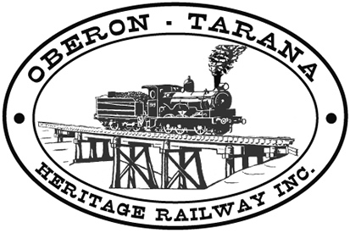 | PO Box 299  Oberon NSW  2787  ABN 98 107 506 208 | Version | Author | Reviewed | Reference
 | PO Box 299  Oberon NSW  2787  ABN 98 107 506 208 | B - Rev 0 | SM | SEC/TM | SN-005
 | PO Box 299  Oberon NSW  2787  ABN 98 107 506 208 | September - 2009
 | PO Box 299  Oberon NSW  2787  ABN 98 107 506 208 | Safety Vests
Use of Safety Vests

It is a requirement of OTHR’s Safety Management System that any person engaged in Railway Safety Work in or near the rail corridor must wear an APPROVED HIGH VISIBILITY SAFETY VEST or alternative approved clothing.

Please ensure when you are working in the railway corridor that you always wear the safety vests provided or other APPROVED HI VISIBILITY clothing of your choice.

OTHR have two types of vest available:

- Those to be worn during DAYLIGHT only. (No reflective tape)
- Those suitable for daytime and AFTER DARK activities. (These vests have reflective tape). OTHR prefers you to use type 2 similar to that shown below:

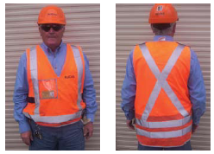

During daytime operations you are permitted to wear either of the above styles.

Orange High Visibility vests are used for general rail safety work.
Yellow High Visibility vests are used only by SHUNTERS.

