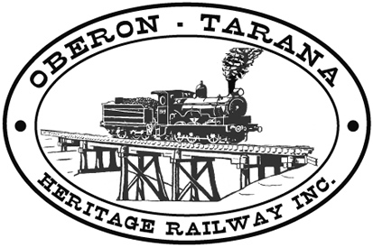 | PO Box 299  Oberon NSW  2787  ABN 98 107 506 208 | Version | Reviewed By | Reference
 | PO Box 299  Oberon NSW  2787  ABN 98 107 506 208 | B - Rev 0 | Sec/SM | SN-010
 | PO Box 299  Oberon NSW  2787  ABN 98 107 506 208 | May - 2009
 | PO Box 299  Oberon NSW  2787  ABN 98 107 506 208 | Site Notice – Safety Committee

SAFETY COMMITTEE

Your Safety Sub-Committee Members are:

TITLE POSITION HELD BY (at Document date)
President Shane Moorhead
Operations Manager Bill Muldoon
Secretary Margaret Conners
Track Manager Peter Culley

The Safety Management Sub-Committee meets monthly to consider & review the Incident Register R-017 and any other Safety Reports.

Review action is required when Risks ranging from Low to Very High are identified in line with RM-001 Risk Management Procedure.

This Committee will also carry out internal audits to make sure people assigned rail safety responsibilities are effectively carrying out their responsibilities.

You are also invited to make representations to the Safety Sub-Committee if you have concerns about hazards or risks you may have identified.

