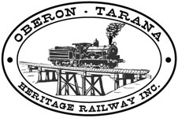 | PO Box 299  Oberon NSW  2787  ABN 98 107 506 208 | Version | Author | Reviewed | Reference
 | PO Box 299  Oberon NSW  2787  ABN 98 107 506 208 | A - Rev 2 | SM | SEC/SM | COM-006
 | PO Box 299  Oberon NSW  2787  ABN 98 107 506 208 | 18 Jul 2012 | SM | SEC/SM | COM-006
 | PO Box 299  Oberon NSW  2787  ABN 98 107 506 208 | Management - Roles & Structure

Management
Roles and Structure

Document Status

Version | Date | Revision | Prepared | Reviewed | Approved
A | Jan 2010 | Rev.0 | SM (Fletcher) | SEC / CEO | Management Committee
A | 13 Feb 2010 | Rev.1 | SM (Fletcher) | SEC / FM | Management Committee
A | 17 Jul 2012 | Rev.2 | SEC | SM | Management Committee

Revision Record
Revision | Date Issued: | Description of change:
1 | 13 Feb 2010 | Logical sequence improved, spacing increased to improve legibility, duties reconfigured to include overarching responsibilities, duty statements revised.
2 | 17 Jul 2012 | Defined additional committee responsibilities in relation to safety and governance, amended org chart, updated current office holders & contact details, added appendix committee agenda & actions list.

Distribution
Hard Copy | Position Title | Electronic Controlled Copy
A-0 | Management Committee | OTHR Website

CONTENTS
1 The Executive Committee 3
2 The Management Committee 3
3 Members of the 2012/13 Management Committee 4
4 Organisational Chart 5
5 Responsibilities and Accountabilities: 6
a) President 6
b) Vice President 7
c) Public Officer 7
d) Secretary 7
e) Minutes Secretary 8
f) Treasurer 8
g) Publicity Officer 8
h) Document Controller 9
i) Website Manager 9
j) Systems Manager 10
k) Operations Manager 10
l) Passenger Services Manager 11
m) Track Manager 11
n) Rolling Stock Manager 12
o) Infrastructure Manager 13
6 Employees, Contractors and Volunteer Safety Workers 13
7 Sub-Committees 14
a) Drug and Alcohol Committee 14
8 Appendix 15
a) Committee Meeting Agenda Template 15
b) Outstanding Actions List Template 16

ROLE DESCRIPTIONS AND ACCOUNTABILITIES
The responsibilities and accountabilities listed below relate to the specific current structure of the OTHR Management Committee which is in accordance with the scope of its current accreditation. Further role descriptions will be developed as the organisational structure of OTHR evolves.

The Executive Committee

The Oberon Tarana Heritage Railway Inc is an association incorporated under the Associations Incorporation Act 2009 NSW, accordingly OTHR has an Executive Committee that controls and manages the affairs of the association in a responsible manner and in compliance with its Constitution.

Under OTHR’s Constitution the executive committee consists of 7 members which are duly elected at its AGM, as follows:
- 4 x “Executive Office Bearers”
  - President,
  - Vice President,
  - Secretary, and
  - Treasurer.
- 3 x Ordinary Elected Members
  - Ordinary Member
  - Ordinary Member
  - Ordinary Member
One of the elected executive members is to be appointed as the public officer.

The executive committee responsibilities include:
- Appointing appropriate & suitable persons into manager roles
- Providing policy direction for the Systems Management System
- Monitoring performance of OTHR operations under its accreditation
- Ensuring the Management Committee administer and adhere to the SMS.
- Ensuring the financial viability of OTHR operations
- Ensuring OTHR complies with all its regulatory obligations

The Management Committee

The persons holding office on the executive committee are also members of the Management Committee which also includes those members who are appointed into the following manager roles by the Executive Committee:
- Systems Manager
- Infrastructure Manager
- Track Manager
- Operations Manager
- Rolling Stock Manager
- Passenger Services Manager
- Training Manager

All managers may appoint an assistant who will assist the Manager and in case of absence act on their behalf.

Members of the Executive Committee may also hold up to two appointed line manager positions.

The Management Committee’s responsibilities include:
- Approving changes to the OTHR Risk Register, Policies and Procedures
- Review of audit reports ensuring appropriate actioning and closure of findings and non-conformances,
- Review of incident reports ensuring appropriate actioning,
- Ensuring Observance and Adherence to the OTHR Safety Management System
- Conducting a regular Review OTHR SMS
- Review of the content and effectiveness of the OTHR Safety Management System for accuracy and validity,

The Committee meets monthly, and is responsible for ensuring the activities of the OTHR are performed in a safe and effective manner. This will be achieved by including amongst its normal business items the consideration of matters pertaining to the operations of OTHR which include reports covering:
- Accreditation and Regulatory changes,
- Safety & Security, Incidents and Audit reports,
- Information from Managers relating to current operations
- Changes and additions to OTHR Risk Register, Policies and Procedures.
- Minutes & reports of Sub-committee meetings.
REFERENCE: Appendix (a): Committee Meeting Agenda Template
Appendix (b): Outstanding Actions List Template

Members of the 2012/13 Management Committee

President Tim Arnison 02 6335 6307 / 0428 250 402
Vice President Shane Moorhead 0407 935527
Secretary Kylie Moorhead 02 6336 0207
Public Officer Graham Parker 02 6336 1076 / 0429 394 770
Treasurer Marjorie Webb 02 6337 5835
Systems Manager Ian Davis 02 6335 6228 / 0438 552 488
Track Manager Peter Culley 0427 042 448

Organisational Chart

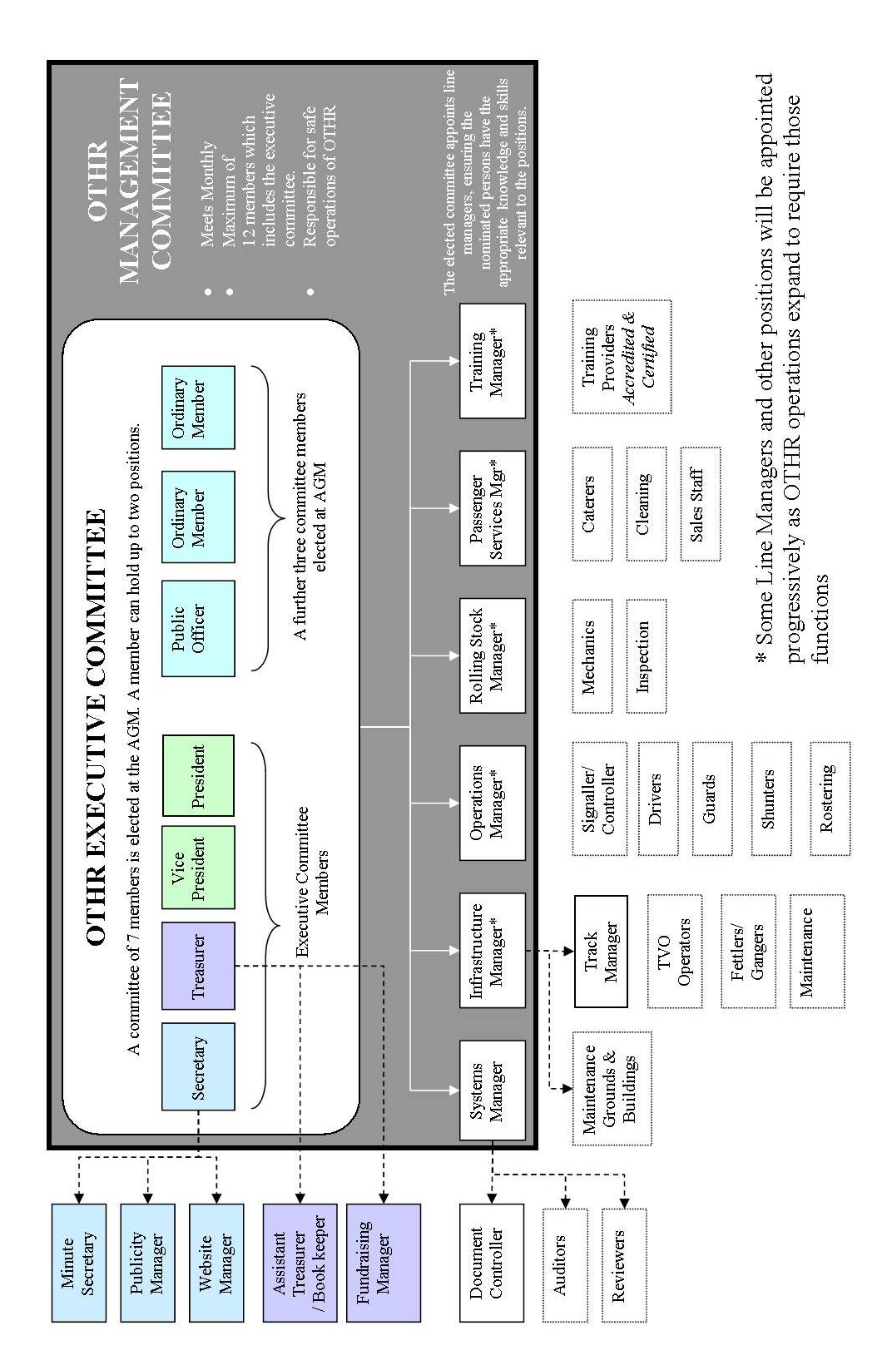

Responsibilities and Accountabilities:
As well as the specific responsibilities and authorities listed against each position below the following safety authorities and responsibilities also apply to all incumbent persons:

All managers have the responsibility to:

- Carry out their duties in a professional manner.
- Manage and control their managerial responsibilities in the best interests of OTHR.
- Comply with OTHR’s SMS provisions and related standards and procedures.
- Implement OTHR’s risk management policies and procedures and ensure that standard operating procedures incorporate risk management concepts.
- Monitor and maintain a healthy and safe work environment

All managers have the specific authority to:

- Prohibit work being carried out by third parties until it is established that the work methods and outcomes are safe
- Initiate action to prevent unsafe occurrences
- Identify, record and report any railway safety issues to the committee
- Initiate, recommend or provide solutions to railway safety issues through the committee
- Initiate action to learn from railway occurrences and to prevent any recurrence
- Verify that any correction actions to safety issues have been implemented
- Carry out random audits to ascertain compliance with safety management systems
In addition to the responsibilities and authorities outlined within this document, additional responsibilities may be described within other individual policy documents within the OTHR SMS.

President
    - Provides leadership to OTHR by implementing the stated aims and objectives.
    - Chairs OTHR meetings.
    - Signs off on all reports to the Safety Regulator (ITSRR) for all matters relating to OTHR.
    - Ensures the financial and safe operation of OTHR.
    - Monitors the performance of all Management Committee members and provides assistance when required.
    - Responsible for conducting a Management Review each appointed line manager on an annual basis to ensure those persons have the skills and resources to enable them to perform their allocated tasks and discharge their allocated responsibilities. This review may be conducted informally.
    - Ensures that OTHR complies with relevant acts and regulations
    - Approves safe work systems.
    - Monitors the operation of the Safety Management Plan (SMP).
    - Represents or delegates others to represent OTHR at meetings with the Office of Rail Heritage (ORH), ITSRR, ARTC, RIC, Oberon Council and other government, local government or heritage rail instrumentalities.

Vice President
    - Deputises for the President and chairs meetings
    - Chairs relevant sub-committees
    - Undertakes specific tasks as directed by the President.

Public Officer
    - Ensures that all of the legal, regulatory and financial obligations imposed upon OTHR by the relevant State and Commonwealth legislation and regulations are complied with in a timely fashion
    - Ensures that all of the Articles of Association of OTHR are complied with
    - Keeps in safe custody the common seal of OTHR and ensures it is affixed to any instrument in the authorised manner
    - Keeps in safe custody and control all records, books and other documents relating to OTHR
    - Establishes and maintains OTHR’s register of members specifying their names and addresses together with the date they became a member
    - Negotiates and arranges all appropriate insurance coverage for the operations of OTHR.

Secretary
    - Receives all of OTHR’s inward correspondence
    - Is responsible for forwarding all outward OTHR correspondence as determined by the President, the Management Committee or a general meeting.
    - Keeps the minutes of all appointments of office-bearers and members of the Management Committee
    - Gives notices to members of the location and date of all general meetings
    - Keeps the names of members of the Management Committee present at a Management Committee meeting and of members at general meetings
    - Keeps minutes of all proceedings at Management Committee meetings and at general meetings
    - Carries out all other duties as directed by the President
    - Prepares the agendas for Committee and General Meetings ensuring all relevant items on the annual schedule are included.
    - Appoints and is responsible for direction of the Minutes Secretary, Publicity Manager and Website Manager

Minutes Secretary

- Records the minutes of meetings of the Management Committee and OTHR’s general meetings
- Maintains the Outstanding Actions List from the minutes and discussions at committee meetings.
- Assists the Secretary with documentation as directed by the Management Committee
- Conducts railway-related research as directed by the Management Committee.

Treasurer

Responsibilities:
- Maintains OTHR’s financial records and affairs
- Is responsible for depositing all income in OTHR’s bank accounts
- Is responsible for the payment of all duly authorised accounts
- Issues receipts for membership fees and donations
- Monitors fundraising income
- Provides monthly statements of income and expenditure to meetings
- Preparation of annual accounts for auditing
- Preparation of the annual financial statements for other parties, including various government departments as required.
- Prepares annual Financial Plans/Budget with the assistance of the committee as required
- Applies for grants from funding bodies.
- Appoints and oversees the activities of the Fundraising manager who organises raffles and other fundraising activities.

Publicity Officer
    - Produces and arranges the distribution of OTHR’s monthly newsletter
    - Writes articles for local, regional, State and national newspapers
    - Organises television coverage of OTHR’s achievements and projects
    - Arranges displays at appropriate outlets to promote OTHR’s achievements and tourist opportunities
    - Undertakes radio interviews with appropriate radio stations
    - Co-ordinates the updating of OTHR’s publicity brochures
    - Gives presentations to tourist and business groups to promote OTHR
    - Co-operates with the Treasurer or Fundraising Manager in organising promotional goods for sale to tourists.

Document Controller
    - Operates under the direction of the Systems Manager.
    - Maintains OTHR’s Safety Management Documents system at the direction of the Systems Manager.
    - Manages the Document Office computer, printer, photocopier and other associated equipment.
    - Provides multiple copies of all working safety documents for managers, team leaders and volunteers. These will normally be available from the Safety Office (outer Station Master’s Office).
    - Provides easy access to frequent-use documents by means of master copies held prominently in the Document Office. These documents may then be photocopied by the Managers.
    - Maintains confidential volunteer competency records under the guidance of the Public Officer; copies of safety returns; and other safety and running records as are required for day to day running by OTHR.

Website Manager
    - Maintains and updates the OTHR website
    - Maintains OTHR’s on-line safety management documentation prior to issue in accordance with OTHR’s policies.
LINE MANAGERS

Systems Manager
    - Responsibilities for:
  - the safety induction documentation for all volunteers, contractors and employees.
  - the development, implementation and evaluation of OTHR’s Safety Management Plan and system.
  - overseeing the creation of system documents such as Job Safety Analyses, “Toolbox Meetings”, Standard Operating Procedures, training and operational manuals etc.
  - developing and assigning persons to carry out Risk Assessments.
  - maintaining the OTHR Risk Register.
  - overseeing the Annual Safety Review and compilation of the Annual Safety Performance Report.
  - overseeing and directing the duties of the Document Controller.
  - preparing an Annual Schedule of items of the SMS which are required to be reviewed, audited and updated for inclusion on the agenda of committee meetings throughout the year (in conjunction with the Secretary)
  - Authority to:
  - ensure that OTHR produces and maintains railway safety documentation covering procedures and instructions
  - ensure the railway safety system controls are effective and auditable
  - ensure that Control and accuracy of SMS documentation is monitored
  - carry out random audits to ascertain compliance with safety management systems
  - conduct “Toolbox meetings” if considered necessary
  - represent OTHR in matters of safety and regulatory compliance with ITSR

Operations Manager
- Oversees day-to-day OTHR Railway operations within the rail corridor.
- Is responsible for the daily management of train operations which, in the current construction phase, involves operation of maintenance “trains” (section car).
- Is responsible for planning the daily management of train operations including the rostering of crews when we move into revenue operations.
- Monitors the training and performance of persons involved in train operations,
- Liaises with the Line Managers during the restoration of the line and subsequently during revenue operations to make sure that:
  - proper integrated planning exists within sections,
  - appropriate budgets are planned for allocation of resources,
  - adequate training provisions are being made,
  - effective inspection and maintenance schedules are set-up,
  - Standard Operating Procedures are implemented and updated,
  - Identifies, assesses and initiates corrective action where workplace hazards and breaches of safety requirements are detected.
- Reviews and takes action on:
  - the monthly safety performance report,
  - drug and alcohol reports,
  - incident reports
  - Reviews the performance of operators of specialised plant and equipment including locomotives, cranes, trucks etc.
  - Carries out safety certification of OTHR’s operational arrangements including personnel management issues and operations procedures and protocols.
  - In conjunction with the Systems Manager, oversees the compilation and update of all documentation and manuals associated with the operation of trains in the corridor.
  - In conjunction with the Systems Manager, certifies the accuracy and completeness of information on operational aspects in the annual Safety Performance Report.
  - May carry out random Audits to ascertain compliance with safety management systems.

Passenger Services Manager
Once OTHR is running passenger operations, this role is responsible for the customer service areas including catering, cleaning, staffing of museum exhibits and ticket and merchandise sales.

Whilst the project is in its restoration phase, this role is responsible for:
- Co-ordinates meals for volunteers at working bees
- Co-ordinates food to be provided for special events
- Is responsible for the maintenance and cleanliness of the food preparation and serving areas including the cooking utensils and equipment.
- Manages the training needs for catering staff.

Track Manager
    - Responsible for all railway tracks, cuttings, drainage works, track support earthworks and level crossings.
    - Organises and oversees the restoration of the railway track between Oberon and Tarana.
    - Develops a work plan of all tasks to be undertaken to restore the line between Oberon and Tarana.
    - Develops an annual proposed budget for the Management Committee.
    - Sets dates for working bees in conjunction with the Management Committee.
    - Allocates volunteer track workers to specific tasks with contingency plans for varying numbers of attendees.
    - Monitors volunteers’ work to ascertain that all aspects of OTHR’s Safety Management System are being observed
    - Conducts “Toolbox Meetings” or delegates this task to appropriately qualified OTHR members and records questions and comments from participants onto the toolbox meeting topic sheet.
    - Submits quotations for the purchasing of equipment and supplies associated with track laying tasks including related safety requirements
    - Specifies appropriate safety requirements when requesting purchase of goods
    - Liaises with all relevant Managers and the Catering Manager for the planning of working bees
    - Implements OTHR’s worker fatigue, incident, health and drug and alcohol policies
    - Identifies and assesses workplace hazards.
    - May carry out random Audits to ascertain compliance with safety management systems.

Rolling Stock Manager
    - Maintains in safe working order all of OTHR’s rollingstock
    - Sets maintenance schedules and supervises repairs to rollingstock
    - Identifies and assesses workplace hazards related to rollingstock
    - Conducts safety certification of rollingstock and related equipment and procedures
    - Selects and supervises service providers for rollingstock maintenance and testing, including specification of safety requirements.
    - May carry out random Audits to ascertain compliance with safety management systems.

Infrastructure Manager
    - Maintains, within the rail corridor, all station buildings, works and maintenance buildings and fixed structures (besides the track which is managed by the Track Manager) including supports for signalling and telecommunications equipment but excluding that equipment.
    - Sets maintenance schedules and supervises repairs to the structures described above.
    - Identifies and assesses workplace hazards related to asset infrastructure.
    - Conducts safety assessment of infrastructure.
    - Selects and supervises service providers for infrastructure maintenance and testing, including specification of safety requirements.
    - Carries out regular stocktakes as required by the Management Committee.
    - Utilises the data to advise the Management Committee on projected needs or shortfalls; on asset deterioration and on damaged assets.
    - Needs to reference our Asset Management Policy, and whether the AM is responsible for the implementation of that.
    - .

Employees, Contractors and Volunteer Safety Workers
Whilst not part of the Management Committee, Employees, Contractors and Volunteer Safety Workers need to:
- Comply with OTHR’s SMS provisions and related standards and procedures.
- Implement OTHR’s risk management policies and procedures.
- Perform allotted duties in accordance with OTHR’s documented procedures.
- Report safety issues and suggestions for solutions in accordance with OTHR reporting procedures. If unsure, report issues at Toolbox meetings or write, with your concerns, directly to the Secretary.
- Participates constructively in the development and review of safety systems as required.

Sub-Committees
Sub-committees may be established at any time for specific purposes by the Management Committee to which they must report.

These sub-committees may include, but are not limited to the following:
- Finance Sub-Committee
- Audit and Review Sub-Committee
- Event Sub-Committee

The following are standing sub-committees formed for specific purposes and operate under the requirements outlined in the relevant parts of the OTHR Safety Management System:

Drug and Alcohol Committee
The responsibilities and authorities of this committee are as described in POL-004 Drug and Alcohol Policy. The Committee has a standing membership which consists of the following members:
- President
- Operations Manager
- Track Manager
- Secretary

Appendix

Committee Meeting Agenda Template

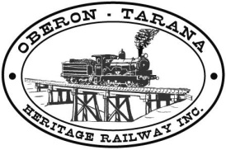
Committee Meeting Agenda
[Insert Date & Time]
[Insert Meeting Location]

Distribution:
President: [Insert Name] |  | Vice President: [Insert Name] |  | Public Officer: [Insert Name]
Secretary: [Insert Name] |  | Treasurer: [Insert Name] |  | Infrastructure Manager: [Insert Name]
Systems Manager: [Insert Name] |  | Operations Manager: [Insert Name] |  | Training Manager: [Insert Name]
Minute Secretary: [Insert Name]
1  2 | Call to Order |  |  |  | Chair
1  2 | Apologies |  |  |  | Chair
3 | Safety Management |  | *Ratify any new/changed SMS Documentation |  | Systems Manager
3 |  |  | *Safety Issues / Incidents / Audit / SMS Review |  | All
4 | Minutes of Previous Meeting |  | Motion: That the minutes from the previous committee meeting as tabled be accepted as true and proper. |  | Secretary
4 | 4.1 Business Arising |  | Business arising from previous minutes |  | All
 | 4.2 Outstanding Actions |  | Review & Update of Outstanding Actions List |  | All
5 | Correspondence In: |  | Out: |  | Secretary
5 | 5.1 Business Arising from Correspondence
6 | Committee Reports
 | 1. President’s Report |  |  |  | President
 | 2. Vice President’s Report |  |  |  | Vice-Pres
 | 3. Public Officer’s Report |  |  |  | Pub-Off
 | 4. Track Manager’s Report |  |  |  | Track Mgr
 | 5. Systems Manager’s Report |  |  |  | Systems
 | 6. Treasurer’s Report |  |  |  | Treasurer
 | 7. Other Manager / Subcommittee Reports
7
  General Business
8 | Other Business
9 | Next Meeting: [Date & Time of Next Meeting] |  |  |  | Chair

Outstanding Actions List Template

Committee Outstanding Actions List
as at: [insert date last updated]

Distribution: to each committee member plus any other responsible person
who is specifically nominated with an action.
Instruction: Decisions made at Committee and General Meetings, especially those regarding safety will be entered onto the list below, along with the initial date of the decision, and if applicable, the expected completion date.
The list will be reviewed at each subsequent meeting, and items will remain until they are completed.
Responsible Person | [Date] – Description of Action
[insert name] | - [Initial Meeting Date] – [Description of action including due date if applicable]  - [Initial Meeting Date] – [Description of action including due date if applicable]
[insert name] | - [Initial Meeting Date] – [Description of action including due date if applicable]
[insert name] | - [Initial Meeting Date] – [Description of action including due date if applicable]
[insert name] | - [Initial Meeting Date] – [Description of action including due date if applicable]
[insert name] | - [Initial Meeting Date] – [Description of action including due date if applicable]
[insert name] | - [Initial Meeting Date] – [Description of action including due date if applicable]
[insert name] | - [Initial Meeting Date] – [Description of action including due date if applicable]
[insert name] | - [Initial Meeting Date] – [Description of action including due date if applicable]
[insert name] | - [Initial Meeting Date] – [Description of action including due date if applicable]

UPCOMING IMPORTANT DATES TO NOTE:

