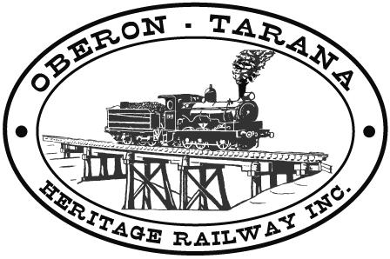
Oberon Tarana Heritage Railway Inc. Date:8th December 08

Tarana to Gemalla Interface Contact List
Function | Name,  Position | Telephone |  | Comments
Function | Name,  Position | Landline/Mobile | Fax | Comments
Emergency Services | Duty officer | 000 |  | Ambulance,  police, fire,  rescue services
Environmental Protection  agency | Duty Officer | 13 15 55 |  | 24hr service
ITSRR | Duty Officer | 1800 677 766 | 02 8263 7297 | 24hr service
Poisons Information  Centre. | Duty Officer | 13 11 26 |  | 24hr Service
WorkCover  - Orange | Duty Officer | 13 10 50  6392 7600 |  | 24hr Service
Local SES | Duty Officer | 132 500 |  | 24hr service
Oberon Shire Council  - Office  - Depot  - After hours  - Dog & Stock | Duty Officer  Duty Officer | 63 298 100  63 298 200  0428 698 036  6336 0463 |  | 8.30am to 4.30pm  24hr service
Hospitals  - Oberon  - Bathurst |  | 6336 1300  6339 5311 |  | 24hr Service
Country Energy | Duty Officer | 1800 641 424 |  | 24hr service
Gas Emergency | Duty Officer | 13 1909 |  | 24hr service
Roads & Traffic  Authority | Duty Officer | 13 2701 |  | Road closures and  special events.
ARTC | Ian Crosier | 0429 600 317 |  | Site Manager
Laing O’Rourke | Eric Williams | 0428 403 077 |  | Protection  Officer in charge
Laing O’Rourke | Mark Hill | 0418 291 984 |  | Site Manager
Laing O’Rourke | Dave Whitehead | 0428 695 594 |  | Asst site Manager
Site Communication | All stations | UHF Ch 18 |  | Everybody
OTHR | Peter Culley | 0427 042 448 |  | Track Manager
OTHR | Shane Moorhead | 0407 935 527 | 63 360 119 | Acquisitions officer
OTHR | Tim Arnison | 0428 250 402 |  | Asst track Manager
OTHR | Bill Muldoon | 0427 361 438 |  | President.
OTHR | George laidlaw | 0411 018 178 |  | Protection officer

Form: OTHR-F-023

