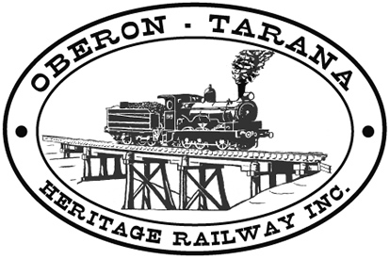 | PO Box 299  Oberon NSW  2787  ABN 98 107 506 208 | Version | Reviewed By | Reference
 | PO Box 299  Oberon NSW  2787  ABN 98 107 506 208 | B - Rev 0 | Sec/SM | F-031
 | PO Box 299  Oberon NSW  2787  ABN 98 107 506 208 | May - 2009
 | PO Box 299  Oberon NSW  2787  ABN 98 107 506 208 | Daily Plant Checklist - Vehicles

Date: _______________Job Site: __________________________________
Plant description: |  | Contractor Name;
Make & Model: |  | Rego or Permit No:
Serial Number: |  | Expiry date:
Year Made: |  | Daily crane check list attached (please tick)
Hour Meter Current: |  | OTHR Plant No:

Item |  |  |  | OK Tick |  | Item |  |  | OK Tick | Item | OK Tick
Neutral Start: |  |  |  |  |  | Daily check list in plant |  |  |  | Air Conditioning:
Service Brakes: |  |  |  |  |  | Wipers: |  |  |  | Windows:
Park/Emergency Brake: |  |  |  |  |  | Lights and reflectors: |  |  |  | Engine
Seat Belt: |  |  |  |  |  | Reflective tape: |  |  |  | - Oil Level:
Rev/Travel alarm: |  |  |  |  |  | Horn: |  |  |  | - Cooling sys
Compulsory signs: |  |  |  |  |  | Amber Beacon: |  |  |  | - Exhaust sys
Hitches (incl safety pins) |  |  |  |  |  | Mirrors: |  |  |  | - Leaks
Guards: |  |  |  |  |  | Registration Label: |  |  |  | Body/Cabin:
Environmental spill kit: |  |  |  |  |  | Plant Security: |  |  |  | Trans & Final Drive
 |  |  |  |  |  |  |  |  |  | Hydraulics:
 |  |  |  |  |  |  |  |  |  | Chassis / Frame:
Operators  Name | Check List  Sighted -  Signature |  | Drivers  Licence  No |  | WorkCover  Licence  Nos. |  |  | OTHR  Induction  No. |  | Suspension:
Articulated joint /
Linkages:
 |  |  |  |  |  |  |  |  |  | Tyres and wheels:
 |  |  |  |  |  |  |  |  |  | Tracks:
 |  |  |  |  |  |  |  |  |  | Controls:
 |  |  |  |  |  |  |  |  |  | Seat:
 |  |  |  |  |  |  |  |  |  | Steering:
 |  |  |  |  |  |  |  |  |  | Electrical System:
 |  |  |  |  |  |  |  |  |  | Attachments / Tools:
 |  |  |  |  |  |  |  |  |  | ROPS / FOPS:
 |  |  |  |  |  |  |  |  |  | Enclosed Cabin:

Comments / defects / action taken for any UN-TICKED items:
_______________________________________________________________________________________________________________________________________________________________________________________________________________________________________________________________

Operator________________ (printName) ____________________ (Signature) ____/____/_____(date)

 Tick box if Crane (Please fill in additional Page OTHR-F-032)
 Tick box if Plant & Equipment Non–Conformance Report is to be completed. (OTHR-F-032)

