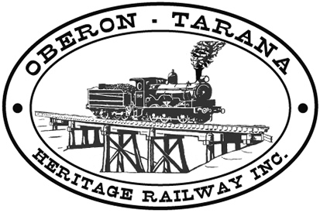 | PO Box 299  Oberon NSW  2787  ABN 98 107 506 208 | Version | Reviewed By | Reference
 | PO Box 299  Oberon NSW  2787  ABN 98 107 506 208 | B - Rev 0 | Sec/SM | F-033
 | PO Box 299  Oberon NSW  2787  ABN 98 107 506 208 | May - 2009
 | PO Box 299  Oberon NSW  2787  ABN 98 107 506 208 | Daily Plant Checklist - Cranes
NOTE: OTHR-F-031 Daily Plant Checklist MUST BE COMPLETED AS WELL

Date: _______________Job Site: __________________________________
Tyre  Condition | Position 1 |  | Position 3 |  | Position 5
Tyre  Condition | Position 2 |  | Position 4 |  | Position 6

Tyre  Pressure | Position 1 |  | Position 3 |  | Position 5
Tyre  Pressure | Position 2 |  | Position 4 |  | Position 6
Slew System | OK  Tick | Winches | OK Tick |  | Outriggers | OK  Tick
Slew System | OK  Tick | Winches | Main | Aux | Outriggers | OK  Tick
Slew Sling |  | Mounting Bolts |  |  | Vertical Cylinder Leaks
Slew motor leaks |  | Oil Leaks- Gear Box |  |  | Vertical Cylinder hoses
Slew box leaks |  | Oil Leaks- Hyd motor |  |  | Horizontal Cylinder leaks
Slew box mounting bolts |  | Brake lining /adjustment |  |  | Horizontal Cylinder hoses
Slew box oil level |  | Brake Oil/Fluid leaks |  |  | Outrigger pad condition
Slew brake operation |  | Drum Cracks |  |  | Horizontal Slides
Slew brake adjustment |  | Safety Pawl operation |  |  | Outrigger Box Cracks
Rotary connection leaks |  | Disorderly rope winding |  |  | Outrigger pin and retainers
Upper Hourse lock pin |  | Oil level/ Gearbox
 |  |  |  |  | Boom
 |  |  |  |  | Hoist Cylinder leaks
 |  | Ropes and Hooks |  |  | Hoist Cyl Pins and Retainers
 |  | Rotation of hook |  |  | Hoist Cyl Hose condition
 |  | Deformation of hook |  |  | Boom pivot pin and retainers
 |  | Safety latch fitted |  |  | Inspect boom for cracks/damage
 |  | Deformation of rope guard |  |  | Sliding wear pad condition
 |  | Rotation of Sheaves |  |  | Telescopic cylinder leaks
 |  | Lubricate Sheaves |  |  | Telescopic cylinder hoses
 |  | Kinks in wire Rope |  |  | Angle indicator condition
 |  | Broken strands in Rope |  |  | Inspect fly for Damage
 |  | Corrosion of Rope |  |  | Fly retaining pins and supports
 |  | Wedge correctly fitted |  |  | Fly Storage correct
 |  | Rope clip fitted to End |  |  | Boom Sheaves
 |  |  |  |  | Fly Sheaves

Comments / defects / action taken for any UN-TICKED items:
_______________________________________________________________________________________________________________________________________________________________________________________________________________________________________________________________

Operator________________ (printName) ____________________ (Signature) ____/____/_____(date)

 Tick box if Plant & Equipment Non–Conformance Report is to be completed. (OTHR-F-032)

