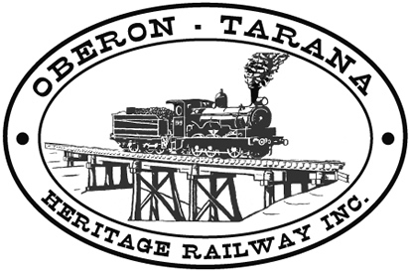 | PO Box 299  Oberon NSW  2787  ABN 98 107 506 208 | Version | Author | Reviewed | Reference
 | PO Box 299  Oberon NSW  2787  ABN 98 107 506 208 | A - Rev 1 | SM | SEC/TM | F-045
 | PO Box 299  Oberon NSW  2787  ABN 98 107 506 208 | 23/09/16
 | PO Box 299  Oberon NSW  2787  ABN 98 107 506 208 | TMV/Section Car - Safety Check

SECTION CAR SAFETY CHECK.

(Driver retains with the Authority to Operate and returns to office at conclusion of Authority.)

Authority #……………….. Date Issued……………….. Time Issued…………

Before use, the following safety checks were carried out to the best of my ability and I
Consider that the Section Car is in safe working order ………………………………
Signed – Driver

[TICK IF SATIFACTORY] Tick

- All crew are financial Members of OTHR.
- All crew are wearing PPE including SAFETY VESTS
- The total number of crew is 4 or less.
- The RED danger flag is in place on the Section Car. …….
- The fire extinguisher is in place and within use-by date. …….
- There are no fuel leaks. …….
- Wheels appear secure and not fractured. …….
- There are no obviously damaged mechanical parts. …….
- The brakes check OK when tested. …….
- The rotating safety beacon is tested and switched ON. …….
- The horn is tested and working. …….
- Lights (if fitted) are working …….
- Tools and equipment are loaded safely and suitably restrained. …….
- All crew can be safely seated within the confines of the car. …….
- Other personnel are made aware that operations are about to commence. …….

TO BE RETURNED
TO THE OFFICE AT CONCLUSION OF AUTHORITY

