 | PO Box 299  Oberon NSW  2787  ABN 98 107 506 208 | Version | Author | Reviewed | Reference
 | PO Box 299  Oberon NSW  2787  ABN 98 107 506 208 | A - Rev 0 | SM | SEC/TM | IM-004
 | PO Box 299  Oberon NSW  2787  ABN 98 107 506 208 | 5 October - 2009
 | PO Box 299  Oberon NSW  2787  ABN 98 107 506 208 | Incident Management

Emergency Site Access – Stage 1
Oberon to Hazelgrove

Document Status

Version | Date | Revision | Prepared | Reviewed | Approved
Draft | 19 July 2006 |  | SM (McMahon) |  | Management Committee
A, B, C | Aug 06, 07, 08 | Rev.0 | SM (McMahon) | S. Moorhead  B Muldoon | Management Committee
D | 5 Oct 2009 | Rev.0 | SM (Fletcher) | SEC / TM | Management Committee

Revision Record
Revision | Date Issued: | Description of change:

Distribution
Hard Copy | Position Title | Electronic Controlled Copy
D-0 | CEO, SEC, OM, SM, TM | OTHR Website

Background.

During the re-construction and operation phases, Oberon Tarana Heritage Railway Inc. (OTHR) needs to provide emergency access details to:
- Volunteers and rail safety workers,
- Contractors,
- Council Workers,
- Adjacent Landholders,
- Local emergency services including:
  - Ambulance,
  - Police,
  - Fire Brigades,
  - SES
- Statutory Authorities – Gas, Electricity, Water, Communications.

This will help speed up response time and aid in directions in the event of an accident, injury, illness or other incident while volunteers work on the restoration of the line or during operations.

The work area covered by Stage One is from the buffer stop within Oberon Yard to Hazelgrove station yard. This section covers about 5.6km of line that is accessible from public roads and through private property.

Section Control

Stage one has been divided into two sections. These have been given the following colours to identify the areas and the specific access points.

Red Oberon Station to the Tip road.

White Tip Road to Hazelgrove Station.

The Site Manager or Team Leader will notify the emergency services in the event of a serious non life threatening injury or incident. If some one is seriously injured and it is considered life threatening, the team leader will implement the emergency procedures as laid down by OTHR and contact the required services direct. Procedures are laid down in IM-002 Summary Notifiable Occurrences.

Where possible, OTHR will have a person meet the emergency vehicle at one of these access locations. Gates should be left as found.

OTHR Emergency Evacuation Procedure.

The Evacuation of a work area may be necessary due to a number of reasons:
- Fire
- Bomb treat
- Gas Leak
- Earthquake
- Explosion
- Storm

If the supervisor advises you to leave the area you should;
- Immediately cease the work you are doing.
- Precede to the emergency assembly point, generally the vehicle you came in or a designated area at the work site.
- Wait for your supervisors instructions.
- Do not leave the area unless you notify the supervisor.

The supervisor or team leader will contact the required services as required.

OTHR Incident Procedure.

See IM-002 Summary of Notifiable Occurrences

DEFINITION: a Notifiable Occurrence means an accident or incident that has, or could have, caused significant property damage, or serious injury, or death OR is of a class prescribed by regulations.
(Rail Safety Act 2008, Part 1 – 4 Interpretation)
Notifications are to be returned on ITSRR Form 6 within 72 hours of becoming aware of the Occurrence.
Note: Positive drug and alcohol test results are notified using the Drug and Alcohol Testing Incident Notification (ITSRR Form 1)

Category ‘A’ (The most serious occurrences)
For Category ‘A’ notifiable occurrences also notify the Office of Transport Safety Investigation Duty Officer as soon as practicable after becoming aware of the occurrence on:

1800 677 766 (24 hour service)

Prepare to report:
- The name of the railway organisation: OBERON TARANA HERITAGE RAILWAY Inc.
- The NAME and PHONE NUMBER of a contact person who has full details of the incident and is preferably at the scene.
- WHERE the incident occurred:
  - Nearest recognised location eg. Oberon, Tarana.
  - Description of the exact location including, if known, the Sector details in Site Notices – White Sector & Red Sector
  - Date: dd/mm/yy (eg. 23/05/09)
  - Time: 24 hr clock format (eg. 1755)
- BRIEF DETAILS of the incident, e.g. Passenger train derailed, level crossing accident, fire etc.
- CONSEQUENCES: category of person (eg. staff, contractor, volunteer, passenger, public, trespasser); number of fatalities/injuries; emergency service attendance; emergency management which has been implemented.

Follow-up written notification on the ITSRR Notification of Occurrence Form 6, must be forwarded to the Independent Transport Safety & Reliability Regulator within 72 hours of the incident occurring.

If specific fire procedures apply to your work area (eg. in the case of a Hot Work Permit) then these will govern the emergency steps to be taken in the event of fire.

Otherwise an alarm should be raised immediately if a fire is detected. If required the fire brigade should be called. (Ring 000) make your self familiar with the location of fire extinguishers in your work place, the type of fire they are designed to fight and the methods of operation.

If you use an extinguisher, inform the supervisor who will arrange for a replacement.

At no time try, to combat a fire which is in such a position that will cause you, or other persons close by, personal risk. Do not attempt to control the fire unless it can be dealt with quickly.

During total Fire bans, the lighting of fires is prohibited.

OTHR Emergency Contact List.
(See IM-001)
Function | Contact | Telephone | Comments
Emergency Services | Duty officer | 000 | Ambulance,  Police,  Fire Brigade,  Rescue Services
ITSRR | Duty Officer | 1800 677 766  Fax 02 8263 7297 | 24hr service
Hospitals  - Oberon  - Bathurst |  | 6336 1300  6339 5311 | 24hr Service
Police  - Oberon  - Bathurst |  | 6336 1000  6332 8699
RFS – Rural Fire Service  - Oberon  - After Hours | Duty Officer | 6336 0493  0428 650 470
Local SES | Duty Officer | 132 500 | 24hr service
EPA - Environmental Protection Agency | Duty Officer | 131 555 | 24hr service
Poisons Information Centre. | Duty Officer | 131 126 | 24hr Service
WorkCover  - Orange | Duty Officer | 131 050  6392 7600 | 24hr Service
Oberon Shire Council  - Office  - Depot  - After hours  - Dog & Stock | Duty Officer  Duty Officer | 6329 8100  6329 8200  0428 698 036  6336 0463 | 8.30am to 4.30pm  24hr service
Country Energy – Electricity Supply | Duty Officer | 1800 641 424 | 24hr service
Gas Emergency | Duty Officer | 131 909 | 24hr service
RTA - Roads & Traffic Authority | Duty Officer | 132 701 | Road closures and special events.
Private Crossings  - Peter Hanrahan - 446 Lowes Mt Rd  - R Christie-Johnston - 1st property North of Rutters Ridge Rd  - Clive McCarthy – 1st property North of the Factory Complex |  | 6336 1775  6336 0152  6336 1019 | Property owners  with access over the line.
OTHR MANAGEMENT: | President  Operation Mgr.  Track Manager  Secretary | 0407 935 527  0427 361 438  0427 042 448  0428 635 489 | H - 6336 0207  H - 6336 1203  H - 6336 0228  H - 6336 1211

Red section Details. Total length 3.4km (Oberon Station to the Tip road)

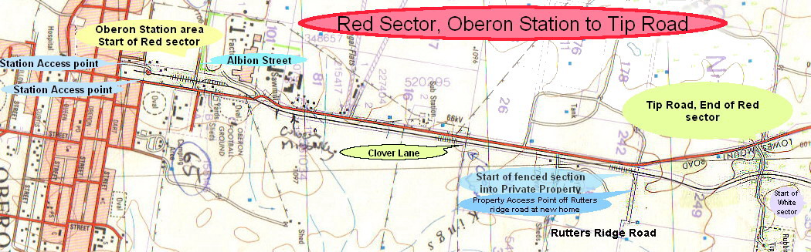

The Red Sector is completely accessible for almost its entire length as the line follows the Lowes Mount Road towards Tarana.

The section between Rutters Ridge Road and Black Bullock Road is within private property and is accessible by 2wd in dry times only.

From Rutters Ridge Road the access towards Hazelgrove for Emergency Vehicles is from the gates off Rutters Ridge Road (to the right-hand side, or East of the line) near the first property on the left - Rural address # 9, Mr Ian Christie-Johnston.

From the Tip Road, cross the level crossing, take first gate on your right and travel south down to the railway line towards Oberon.

As the Tip is only open on some days the preferred access in an emergency is from the Rutters Ridge Road end. However, most Managers have a Tip access key.
IN AN EMERGENCY - FOLLOW DIRECTIONS
& ASSEMBLE AT THE NEAREST SAFE EXIT POINT

Where possible, OTHR will have a person meet the emergency vehicle at one of these access locations. Gates should be left as found.
White section Details. Total Length 1.6km (Tip road to Hazelgrove Station)

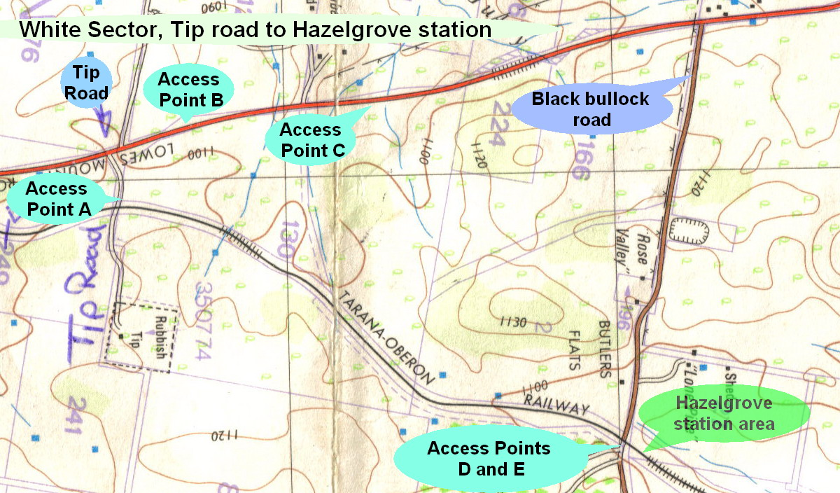

The White Sector is accessible at several locations; however, it requires entry from Council ground and private property. 2 WD is possible in most areas however, 4 WD is advised especially in wet weather.
ACCESS & EXIT POINT A - is off the Tip Road on the left just after the level crossing; (Another entry not marked above is further up the Tip Road on your left. Follow the road back to the railway after accessing the gate). As the Tip is only open on some days the preferred access in an emergency is Point C or D. Most Managers have a Tip access key.
ACCESS & EXIT POINT B - is about 200 metres on from the tip road and is identified by the rural address # 372. Two gates need to be opened and closed as stock are present in these paddocks.
ACCESS & EXIT POINT C (Rural address # 446 of Mr Peter Hanrahan) is only to be used in an emergency. Enter the property and just prior to the house turn left, through the gate, follow the road to the north east, proceed through another gate, then follow the wheel tracks to the higher ground on your left. Once at the summit you will see a gate to your right about 800metres away. This is the owner’s access across the Walking trail.

ACCESS & EXIT POINT D - is off Black Bullock Road at the level crossing. A new gate on the southern side is Access point D. This track is only suitable for 4wd vehicles but gives access to the entire section. In wet times the track may become un-trafficable as a swamp needs to be traversed 200 metres from the gate.

ACCESS & EXIT POINT E is to the north and gives access to the Hazelgrove station area; there is a road on each side of the level crossing.

IN AN EMERGENCY - FOLLOW DIRECTIONS
& ASSEMBLE AT THE NEAREST SAFE EXIT POINT

Where possible, OTHR will have a person meet the emergency vehicle at one of these access locations. Gates should be left as found.

