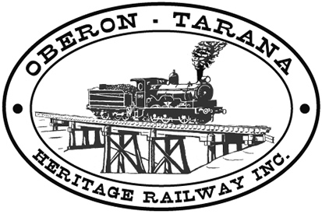 | PO Box 299  Oberon NSW  2787  ABN 98 107 506 208 | Version | Reviewed By | Reference
 | PO Box 299  Oberon NSW  2787  ABN 98 107 506 208 | A - Rev 0 | SEC/SM 17.9.12 | IND-002
 | PO Box 299  Oberon NSW  2787  ABN 98 107 506 208 | 7th September - 2009
 | PO Box 299  Oberon NSW  2787  ABN 98 107 506 208 | Visitor Safety at OTHR
VISITOR WORKSITE SAFETY INDUCTION

Oberon Tarana Heritage Railway Inc (OTHR) welcomes you as a visitor to our heritage railway project. We are committed to ensuring that your stay with us is SAFE and enjoyable. There are some basic requirements that we ask you to comply with to ensure that your safety is protected.

- Individuals must Sign IN using our Visitors Book on arrival and Sign OUT when you leave. For groups (eg. students), the group leader (eg. teacher) signs on behalf of the group.
- OTHR has a rigorous policy with regard to the consumption Drugs and Alcohol - if there is any chance that you may be under the influence of Drugs or Alcohol - PLEASE DO NOT ENTER THE SITE!
- Depending on the area you visit, you may need Personal Protective Equipment with the minimum requirement being:
  - A High Visibility safety orange vest (loan vests are available).
  - Enclosed footwear - thongs and sandals are unacceptable.

- In high risk areas you may also need:
  - A safety helmet (loan helmets are available with a disposable hair net).
  - Steel capped boots.
  - Safety Glasses
  - Hearing Protection
  - Full length clothing (trousers and shirts).

- Stay with your appointed guide and listen carefully to his/ her instructions which are designed to ensure your safety.
- Use COMMON SENSE in moving around the site as there are numerous obstructions in a working railway which may cause injury from Trips, Slips and Falls. Look where you are walking and follow your guide closely.
- Do not enter areas which are marked off as a Danger Area with safety tape or fencing barriers.
- There are always risks of falls from platforms or loading banks - KEEP WELL CLEAR OF THE EDGES. Don’t stand with your back to the edge of a platform or loading bank.
- Rolling Stock and Locomotives - unless you are specifically viewing an item under the guidance of an OTHR inducted member, please KEEP OFF all rolling stock, locomotives and rail motors.
- Keep well clear of any moving or operating machinery. Some machinery has wide “swing” (arc of operation) and may suddenly rotate or move - keep at least 10 metres clear.
PLEASE check the emergency EVACUATION MAPS on display for the area you are entering.

