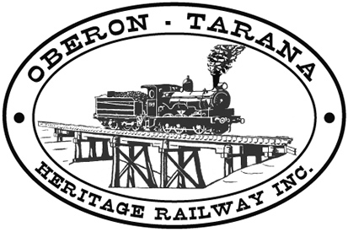 | PO Box 299  Oberon NSW  2787  ABN 98 107 506 208 | Version | Reviewed By | Reference
 | PO Box 299  Oberon NSW  2787  ABN 98 107 506 208 | B - Rev 2 | SEC | POL-001
 | PO Box 299  Oberon NSW  2787  ABN 98 107 506 208 | 16 July 2014
 | PO Box 299  Oberon NSW  2787  ABN 98 107 506 208 | Rail Safety Policy

Rail Safety Policy

Document Status

Version | Date | Revision | Prepared | Reviewed | Approved
A | Aug 2008 | Rev.0 | SM (McMahon) | M Conners  B Muldoon | Management Committee
B | June 2009 | Rev.0 | SM (Fletcher) | M Conners  B Muldoon | Management Committee

Revision Record
Revision | Date Issued: | Description of change:
1 | 16 Nov 2009 | Policy spelled-out in detail.
2 | 28 Jul 2012 | Simplify wording of policy

Distribution
Hard Copy | Position Title | Electronic Controlled Copy
A-0 | CEO, SEC, OM, SM, TM | OTHR Website
A-1 | Board | OTHR Website


Rail Safety Policy

Oberon Tarana Heritage Railway Inc is committed to our duty of care for the health and safety of our workers, contactors and visitors and to the elimination of work related injuries and illness

Our Safety Goal
Our goal is ZERO Injuries – nobody gets hurt,

Our Safety Principles
- We are all responsible and accountable for safety
- A Safety Culture requires commitment at all levels, good communication, trust and an effective system
- Effective risk management requires understanding, planning, training, consultation and accountability

Our Safety Commitment
- Understand the specific health and safety responsibilities of operating the OTHR. .
- Ensure hazards are identified and the risks are effectively managed.
- Strive to continually improve our safety performance by establishing objectives, implementing plans, measuring performance and reviewing progress.
- Provide appropriate resources, systems of work, training and supervision.
- Complying with legislative requirements and current industry standards
- Ensuring all OTHR managers understand and implement our Safety Management System
- Consultation and cooperation between management, members and volunteers on matters that affect health and safety.
- Workers shall report all hazards, incidents and injuries and will abide by all safety rules and procedures and take reasonable care for the safety of themselves and others.

Authorised

--------------------------------------
Tim Arnison
OTHR President
Date: 15 August 2012

