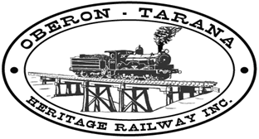 | PO Box 299  Oberon NSW 2787  ABN 98 107 506 208 | Version | Author | Reviewed | Reference
 | PO Box 299  Oberon NSW 2787  ABN 98 107 506 208 | A - Rev 0 | SM | SEC/CEO | R-011
 | PO Box 299  Oberon NSW 2787  ABN 98 107 506 208 | Jan 2010 | RISN Risk Assessments - Register
Document No. | Document  Title | Document Author | Latest Revision | Comments
RM-501 | Risk Assess RISN27 Signalling | SM | 12 Dec 2009 | Relates to the insulation of cable used in safety critical railway infrastructure.  NOT APPLICABLE.
RM-502 | Risk Assess RISN28 Wabtec Braking 120110.doc | SM | 12 Jan 2010 | NOT APPLICABLE
RM-503 | RA for RISN26 Rollingstock Underframe Equipment | SM | 12 Jan 2010
RM-504 | RA for RISN25 Plasser Ballast Tamper | SM | 12 Jan 2010 | NOT APPLICABLE
RM-505 | RA for RISN24 Driver Distractions | SM | 12 Jan 2010
RM-506 | RA for RISN20 Prohibition Riding on Rollingstock | SM | 26 Apr 2010

RISN (Rail Industry Safety Notice) Risk Assessments are numbered in a 3 digit series beginning with 5 (eg. 501)

