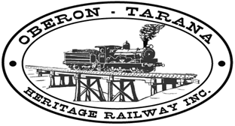 | PO Box 299  Oberon NSW 2787  ABN 98 107 506 208 | Version | Author | Reviewed | Reference
 | PO Box 299  Oberon NSW 2787  ABN 98 107 506 208 | A - Rev 0 | SM | SEC/TM | R-012
 | PO Box 299  Oberon NSW 2787  ABN 98 107 506 208 | 3 Feb 2010 | Incident Management - HAZMAT Register
In accordance with the Occupational Health And Safety Act and the consolidated regulations, all HAZARDOUS SUBSTANCES must be recorded in this register along with the appropriate MSDS (Material Safety Data Sheet).
Ensure that the product is stored, handled and used in accordance with the MSDS and that appropriate PPE (PERSONAL PROTECTIVE EQUIPMENT) is used at all times
ID  No. | TRADE NAME OF SUBSTANCE | SUPPLIER NAME | PHONE No | HAZCHEM  CODE | UN No. | GAS, LIQUID OR SOLID | FLAMMABLE  YES / NO | POISON  YES / NO | USE BY DATE | SAFETY DATA SHEET  YES / NO

