ACTION BY KEY: PR= President, OM= Operations Manager, SM= Systems Manager, SEC= Secretary, PO= Public Officer, TM= Track Manager, FM= Finance Manager,
TR= Treasurer, IM= Infrastructure Manager, IA= Internal Auditor, RM=Rollingstock Manager, TL=Team Leader
Risks in OTHR operation: Oberon Yard Wagon Unload to Rail Affects objective: Safely unload wagon, from transport to RAIL & move to temporary storage area.
Document Date: 27/09/2010 Drafted by: SM Assessed by: Ian Davis……..………
Risk  No. | Hazard  What can go wrong? | Risk  What could happen? | Inherent Risk |  |  | Controls  How could it be fixed? | Residual Risk |  |  | ALARP | Finding:  Issues? Problems? Adopt? | Action
Risk  No. | Hazard  What can go wrong? | Risk  What could happen? | L’hd. | Cons | Risk | Controls  How could it be fixed? | L’hd. | PEC | Risk | ? | Finding:  Issues? Problems? Adopt? | By | When
 | TRANSPORT WAGON TO OBERON
1 | Transport Vehicle  Unqualified and/or uninsured operator. | Injury or death to personnel and property damage. | 3 | 5 | 10 | * Independent check by OTHR on qualifications, currency and insurance. | 2 | 1 | 3 | y | Adopt.  File copies with DC. | PR  SEC  dc | Arrive  -1 week
2 | Transport Vehicle  Safely transport wagon from pick-up point to Oberon | Transport breakdown or miss-hap enroute | 5 | 3 | 8 | Use of specialised rail transporter | 2 | 1 | 3 | y | Adopt.  This operator is well known to OTHR teams and the PR. | PR  tm  RM | Arrive  -1 day
3 | Transport Vehicle  Unsafe footing due to underground services, trenches or embankments. | Transport vehicle has negotiated unloading route twice in the past without incident | 4 | 5 | 9 | * Check with Council & authorities re. location of services.  * Qualified operator. | 2 | 3 | 5 | y | Adopt.  Services have been previously located. | PR  tm | Arrive  -1 day
4 | Transport Vehicle  Unable to reverse up ground in front of station | Vehicle could become bogged in soft ground | 4 | 6 | 6 | Vehicle will be directed up embankment that was previous road and is solid | 2 | 1 | 2 | Y | Adopt  Remove section of fence to facilitate | PR  TM | Arrive  -2 hrs
5 | Transport Vehicle  Unable to line up transport with rail | Wagon wont be able to be unloaded | 3 | 5 | 6 | Operator and assistant will guide transport into correct position. TM will ensure track is accessable | 2 | 1 | 3 | Y | Adopt | PR  TM | Arrive
6 | Preparation for next stage  Wagon may roll away | Wagon may roll away when unloaded from transport | 4 | 5 | 9 | * Apply hand brake.  * Have wheel chocks ready.  * Clamp rail stop to down gradient side.  * Use a sleeper across the line if in doubt. | 1 | 3 | 4 | Y | Adopt all controls - additional sleepers could be used between items of other rolling stock if necessary | PR  TM | Arrive

 | LOCATING WAGON TO RAIL
7 | Aligning Transport to Rail  Transport cant align with track | Unable to unload wagon using the transports inbuilt mechanism | 2 | 3 | 6 | Transport operation crew to perform this task.  OTHR to have contingency plan is wagon cant be unloaded in the normal manner | 2 | 2 | 4 | y | Adopt.  Have contingency plan of crane lift if transport cant be unloaded. | PR  tm  RM | Arrive day
8 | Unloading to Rail | Wagon runaway | 3 | 3 | 6 | Implement step 6 to ensure wagon wont roll on rail | 1 | 1 | 2 | y | Adopt all controls. | PR  tm  RM | Arrive day
 | MOVING WAGON TO SECURE STORAGE POSITION
16 | Move to Storage  Track fails. | Damage to wagon.  Injury to workers.  Damage to property. | 3 | 5 | 8 | * Inspect track before operation. | 1 | 1 | 2 | y | Adopt. | tm | Arrive day
17 | Move to Storage  Runaway due to rail not being level. | Damage to wagon.  Injury to workers.  Damage to property. | 4 | 5 | 9 | * Apply wagon handbrake & repair if ineffective.  * Fit effective backup restraints -sleepers bolted across the line with backup sleepers on the line. | 1 | 1 | 2 | y | Adopt all controls.  Gradient is 1:174 towards Albion St. | PR  tm  RM | Arrive day
18 | Move to Storage  Controlled movement to storage position results in runaway. | Damage to wagon, other rollingstock or infrastructure.  Injury to workers including crushing during movement.  Damage to property. | 2 | 4 | 6 | * Brief machine operator towing rolling stock.  * Clear machine path.  * Use a spotter to advise operator and brake person.  * Check chains and shackles.  * Control movement using r/stock handbrake if effective.  * Chock track at intermediate locations.  * Tow at dead slow.  * Non essential crew to keep well clear. | 2 | 1 | 3 | y | Plan in advance.  Equipment used: 15 tonne tractor crane straddling track, shackled to wagon with a rigid “stiff bar”.  Adopt all controls. | PR  tm  RM | Arrive day
 | SECURE STORAGE
 | The following plan indicates where it is proposed to relocate the 4 wheel wagons onto the line. The red box is the new wagon.
 | 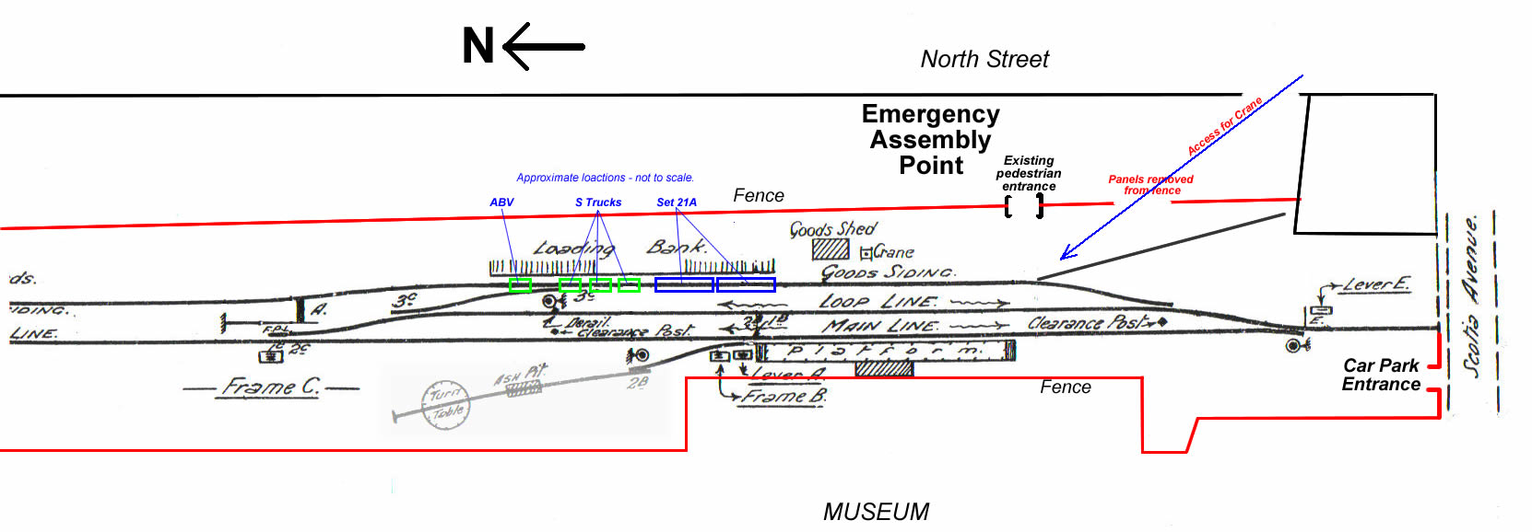

ACTION BY KEY: PR= President, OM= Operations Manager, SM= Systems Manager, SEC= Secretary, PO= Public Officer, TM= Track Manager includes ATM= Assistant TM,
FC= Finance Co-ordinator, TR= Treasurer YET TO BE APPOINTED: IM= Infrastructure Manager, IA= Internal Auditor, RM=Rollingstock Manager
SIGNATURE SHEET - Risk Assessment for: Transport and unloading of Wagon
Risk Assessment associated with OTHR operation described above. Date of Operation: 28/10 /2010
Risk  No. | Hazard  What can go wrong? | Risk  What could happen? | Inherent Risk |  |  | Controls  How could it be fixed? | Residual Risk |  |  | ALARP | Finding:  Issues? Problems? Adopt? | Action
Risk  No. | Hazard  What can go wrong? | Risk  What could happen? | L’hd. | Cons | Risk | Controls  How could it be fixed? | L’hd. | Cons | Risk | ? | Finding:  Issues? Problems? Adopt? | By | When
ALL | As described above. | I have discussed and understand the risks. |  |  |  | I will implement the Controls described above to the best of my ability so that the Risk is managed so that it is  AS LOW AS REASONABLY PRACTICAL. |  |  |  |  | Note any issues you have with the Risks, Management or Controls.
OPERATING CREW.  The operating crew on the day are requested to sign this document indicating that they have READ and UNDERSTOOD the RISKS and CONTROLS associated with this operation. |  | NAME (Print)  …………………………………………………  …………………………………………………  …………………………………………………  …………………………………………………  …………………………………………………  …………………………………………………  …………………………………………………  …………………………………………………  …………………………………………………  …………………………………………………  …………………………………………………  ………………………………………………… |  |  |  | POSITION (Task)  …………………………  …………………………  …………………………  …………………………  …………………………  …………………………  …………………………  …………………………  …………………………  …………………………  …………………………  ………………………… | signature  …………………………  …………………………  …………………………  …………………………  …………………………  …………………………  …………………………  …………………………  …………………………  …………………………  …………………………  ………………………… |  |  |  | COMMENT  ……………………………………….  ……………………………………….  ……………………………………….  ……………………………………….  ……………………………………….  ……………………………………….  ……………………………………….  ……………………………………….  ……………………………………….  ……………………………………….  ……………………………………….  ……………………………………….

