 | PO Box 299  Oberon NSW  2787  ABN 98 107 506 208 | Version | Author | Reviewed | Reference
 | PO Box 299  Oberon NSW  2787  ABN 98 107 506 208 | A - Rev 0 | SM | SEC/TM | SN-006
 | PO Box 299  Oberon NSW  2787  ABN 98 107 506 208 | 6 October - 2009
 | PO Box 299  Oberon NSW  2787  ABN 98 107 506 208 | Spiders & Snakes

Work crews involved in removing old sleepers from the bench have at times uncovered both Funnel Web Spiders and Snakes small and large!
Please take care when handling old sleepers, Remember that even a baby Tiger or Brown Snake no bigger than a pencil can kill you if you get bitten.
If you find one of these poisonous animals while working on the line please advise the team leader immediately.
Clear the area and make the area safe. Don’t aggravate the snake and if possible call a professional snake handler to relocate the snake to a safe distance from the work area.

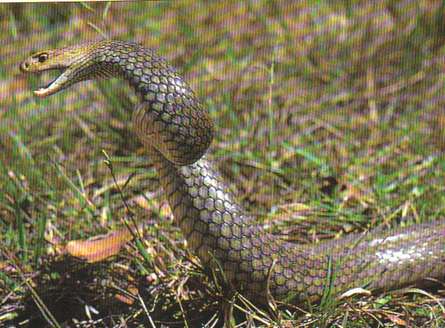
First aid for Snake Bite:
- Do not wash, cut or suck the wound
- Ring 000.
- Apply bandage immediately.
- Firmly bandage starting from the toes or fingers then continue up the limb covering as much of the limb as possible.
- Do not apply any tighter than you would for a sprained wrist.
- Once bandaged, immobilize the bitten limb.
- Keep patient still and calm, movement will increase venom flow.
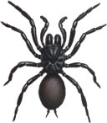
- Monitor pulse and breathing, carry out mouth to mouth & or CPR until the ambulance arrives.
First aid for Funnel Web Spider Bite:

- As for snakebite, using pressure immobilisation method.
- Always try and bring the spider with the patient, for identification at the hospital.

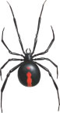
First aid for Red Back Spider Bite:
- Reassure the patient that their life is not at major risk.
- Apply an ice pack to the bite area.
- Seek medical advice.
- Bring the spider with the patient if possible.
- Do NOT use a pressure immobilisation bandage.

