 | PO Box 299  Oberon NSW  2787  ABN 98 107 506 208 | Version | Author | Reviewed | Reference
 | PO Box 299  Oberon NSW  2787  ABN 98 107 506 208 | B - Rev 0 | SM | SEC/TM | SN-011
 | PO Box 299  Oberon NSW  2787  ABN 98 107 506 208 | September - 2009
 | PO Box 299  Oberon NSW  2787  ABN 98 107 506 208 | White Sector Map
Access and Emergency Exit - White Sector
Tip Road to Hazelgrove
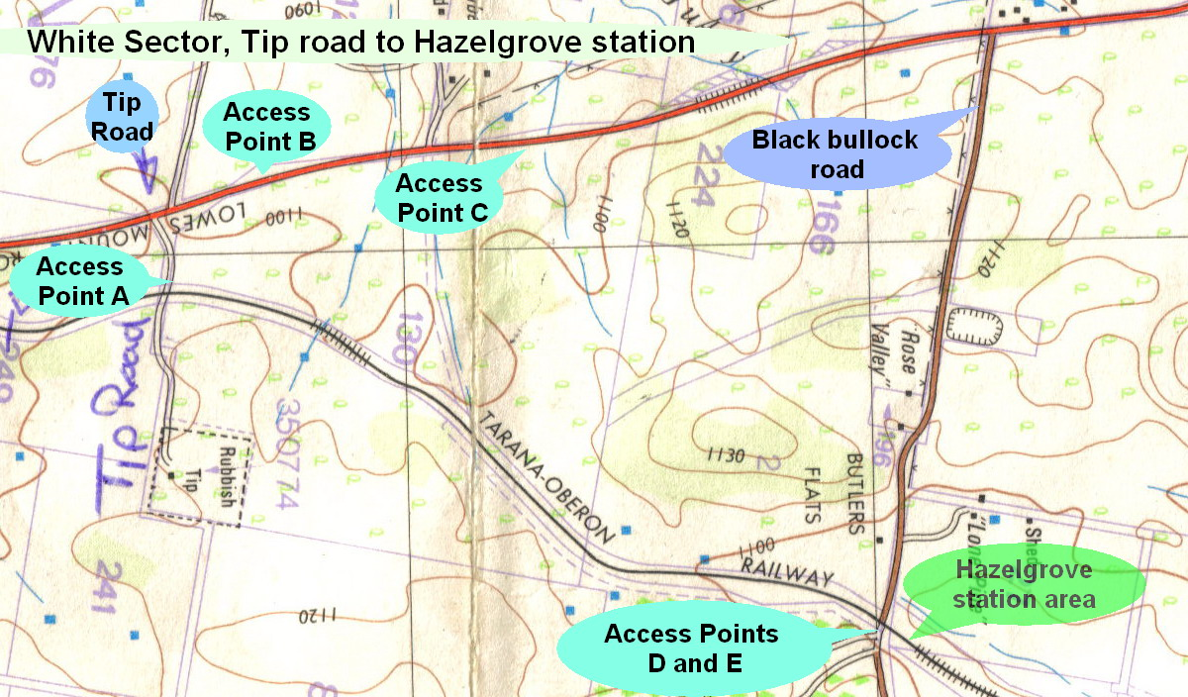

The White Sector is accessible at several locations; however it requires entry from Council ground and private Property. 2 WD is possible in most areas however 4 WD is advised especially in wet weather.
ACCESS & EXIT POINT A - is off the Tip Road on the left just after the level crossing; (Another entry not marked above is further up the dump road on your left. Follow the road back to the railway after accessing the gate). As the Tip is only open on some days the preferred access in an emergency is Point C or D. Most Managers have a Tip access key.

ACCESS & EXIT POINT B - is about 200 meters on from the tip road and is identified by the rural address # 372. Two gates need to be opened and closed as stock are present in these paddocks. These gates are usually locked and should only be used if advised.

ACCESS & EXIT POINT C (Rural address # 446 of Mr Peter Hanrahan) is only to be used in an emergency. Just prior to the house turn left, through the gate, follow the road to the north east, another gate, then follow the wheel tracks to the higher ground on your left. Once at the summit you will see a gate to your right about 800meters away. This is the owner’s access across the Walking trail. These gates are usually locked and should only be used if advised.

ACCESS & EXIT POINT D - is off Black Bullock road at the level crossing. A new gate on the southern side is Access point D. This track is only suitable for 4wd vehicles but gives access to the entire section. In wet times the track may become un-trafficable as a swamp needs to be traversed 200 meters from the gate.

ACCESS & EXIT POINT E is to the north and gives access to the Hazelgrove station area; there is a road on each side of the level crossing.

IN AN EMERGENCY - FOLLOW DIRECTIONS
& ASSEMBLE AT THE NEAREST SAFE EXIT POINT

