 | PO Box 299  Oberon NSW  2787  ABN 98 107 506 208 | Version | Author | Reviewed | Reference
 | PO Box 299  Oberon NSW  2787  ABN 98 107 506 208 | B - Rev 0 | SM | SEC/TM | SN-012
 | PO Box 299  Oberon NSW  2787  ABN 98 107 506 208 | September - 2009
 | PO Box 299  Oberon NSW  2787  ABN 98 107 506 208 | Red Sector Map
Access and Emergency Exit - Red Sector
Oberon Station to Tip Road
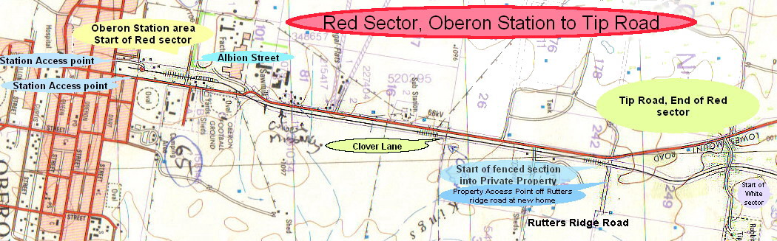

The Red Sector is completely accessible for almost its entire length as the line follows the Lowes Mount Road towards Tarana.

The section between Rutters Ridge Road and Black Bullock Road is within private property and is accessible by 2wd in dry times only.

From Rutters Ridge Road the access towards Hazelgrove for Emergency Vehicles is from the gates off Rutters Ridge Road (to the right-hand side, or East of the line) near the first property on the left - Rural address # 9, Mr Ian Christie-Johnston.

From the Tip Road, cross the level crossing, take first gate on your right and travel south down to the railway line towards Oberon.

As the Tip is only open on some days the preferred access in an emergency is from the Rutters Ridge Road end. However, most Managers have a Tip access key.
IN AN EMERGENCY - FOLLOW DIRECTIONS
& ASSEMBLE AT THE NEAREST SAFE EXIT POINT

