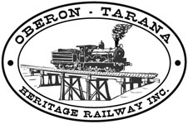 | PO Box 299  Oberon NSW  2787  ABN 98 107 506 208 | Version | Author | Reviewed | Reference
 | PO Box 299  Oberon NSW  2787  ABN 98 107 506 208 | A - Rev 1 | SM | SEC/TM | SOP-003
 | PO Box 299  Oberon NSW  2787  ABN 98 107 506 208 | 11 Jan 2010 | SM | SEC/TM | SOP-003
 | PO Box 299  Oberon NSW  2787  ABN 98 107 506 208 | Standard Operating Procedure

Sleeper Trolley Erection & Use

Document Status
Version | Date | Revision | Prepared | Reviewed | Approved
Draft | 5 May 2009 |  | SM (Fletcher) |  | Management Committee
A | May 2009 | Rev.1 | SM (Fletcher) | M Conners  B Muldoon | Management Committee
A | 11 Jan 2010 | 2 | SM (Fletcher) | SEC. CEO | Management Committee

Revision Record
Revision | Date Issued: | Description of change:
2 | 11 Jan 2010 | Additions made to usage instructions.

Distribution
Hard Copy | Position Title | Electronic Controlled Copy
A-1 | CEO, SEC, OM, SM, TM | OTHR Website
A-2 | CEO, SEC, OM, SM, TM, ATM | OTHR Website

OPERATING CREWS NEED TO READ THIS SOP & SIGN BELOW
Signatures: (attach F-011 Signature Sheet if required)

Name (Print) | Signature | Name (Print) | Signature
Sleeper Trolley – Erection and Use.

The loss of the service road, lack of track access and the problems involved in handling large quantities of sleepers have been addressed by using a purpose built trolley loaned to us by RIC. The trolley was made by the Goulburn Railway Workshops and is certified for a 1.5 tonne load. Sleeper packs, smaller quantities of sleepers or tools are moved along the line from the access point to the current work area by trained Rail Safety Workers.

The use of the trolley must be strictly controlled by the Team Leader. Training in the use of the trolley was originally given by RIC employees and the track manager and senior fettlers are conversant with its use.
The trolley must only be operated by an inducted Member of OTHR who has been trained to use it and who has completed and signed this SOP which covers the erection and use of the trolley.

Erecting the Trolley:
The trolley comes in two halves to simplify transport.
To assemble the trolley carry out the following procedures:

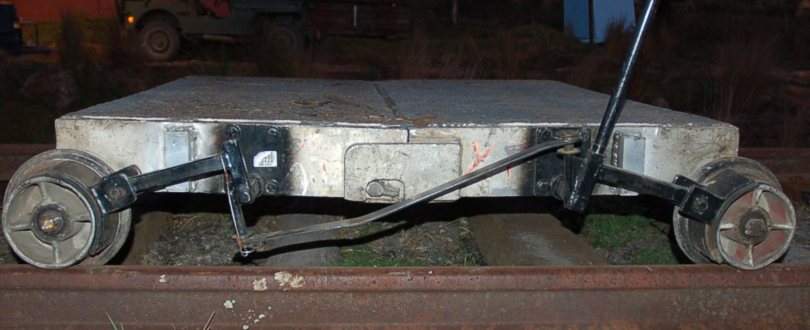
Brakes:
The wheels have compression brakes fitted on the operator side.
The trolley has two heavy springs under the floor that ensure the brakes are on when the handle is released.

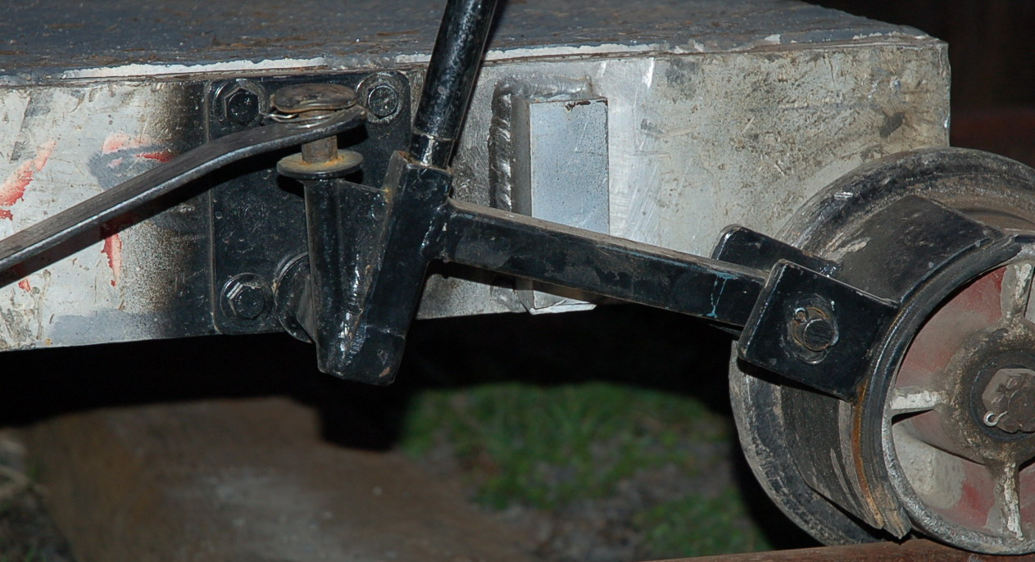
When the operating handle is removed from one of the two operating positions the trolley is unable to be moved in either direction.
The operator uses a special handle to overcome the spring pressure to release the brakes and thus move the trolley along the line.

Loading the Sleeper Trolley:

- Any loading such as tools or dog spikes must be secured and loaded with the weight centralised.
- Place “gluts” (wooden packing spacers) preferably one each over the axles so the load is evenly displaced.
- If full sleeper packs are being moved, they should to be loaded along the direction of the rails. This gives clear access to the brake handle.
- Safety rails (poles or pipes) should be used on operator (brake control) side.
- Only one sleeper pack should be loaded at a time.
- Loading full packs requires the use of a Crane or Forklift and the following P.P.E. MUST BE USED:
  - Steel capped boots,
  - Gloves,
  - Hard Hat.
- Stay well clear of the crane or forklift during loading.
- Sleepers less than pack size may be loaded across the trolley (at right angles to the rails) provided that clear access is available to operate the brake lever.
- Such loading should be restricted so that the sleepers are stable and not liable to fall.
- If in doubt, strap the load together or reduce the number of sleepers carried.
- Be careful of “pinch points” which might jam parts of your body or that of other team members during loading.

Using the Sleeper Trolley:

- The trolley must only be operated by an inducted Member of OTHR who has been trained to use it and who has completed and signed SOP-003 which covers the erection and use of the trolley.
- Always ensure that the brakes are working prior to moving the trolley.
- If the brakes are faulty, report this at once to your team leader and do NOT move the trolley.
- No person is allowed to travel on the trolley.
- Any loading such as tools or dog spikes must be secured and loaded with the weight centralised.
- Before moving, the line ahead should be checked to see that it is clear of workers and tools – STOP if in doubt.
- The trolley should be pushed from behind the direction of travel. It may also be pulled by ropes from outside the “four foot”. Great care must be taken and the trolley moved at slow walking pace.
- A loaded trolley is heavy and difficult to stop so stay well clear until it is stationary.
- Road crossings – the trolley must be stopped before reaching the road. The flangeway should be checked for clearance and raked clean if necessary. If the road is completely clear, the trolley may be pushed slowly across.
- Great care must be taken when crossing culverts or cattle stops and pushing must be done from within the “four foot”, standing on the sleepers and the trolley moved at a slow walking pace.
- When at the work site, the trolley should be prevented from “running away” by using dead stops – these may be simply a sleeper across the line or a purpose designed “stop” clamped to the rail.
- If you need to dismantle or assemble the trolley be careful of “pinch points” which might jam parts of your body or that of other team members. The folding mechanism needs to be treated with care!

