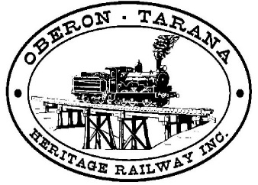  PO Box 299  Oberon NSW 2787  ABN 98 107 506 208 | Version | Author | Reviewed | Reference
 | A-Rev2 | SMS Work party |  | SOP-006
 | 23/04/2018
 | Clipping Points – Yard Operation

Document Status
Version | Date | Revision | Prepared | Reviewed | Approved
A | 23/11/2012 |  | SM | Committee | 24/11/2012
A-Rev2 | 01/04/2018 | 2 | SMS Working Party | Committee | 23/04/2018

Revision Record
Revision | Date issued | Description of Changes
1 | 24/11/2012 | Minor changes
2 | 01/04/2018 | Formatting, deleting Swing Nose and Tangential crossings

Clipping Points – Yard Operation
SOP-006

1: Introduction
Point clips are used to secure points in the normal or reverse position.

Facing points on running lines must be locked if:

- you cannot be sure that the points will remain in the correct position, or
- there is an instruction at the points to clip and lock them.

A lock may also be used on the clip to ensure the point clip is not removed, authority to use a lock or not is with the Track Manager.

2: Using Point Clips
Use standard point clips for standard points. Standard points have a switch blade and stock rail of similar depth. The standard point clip has a simple hook for the switch blade flange.

