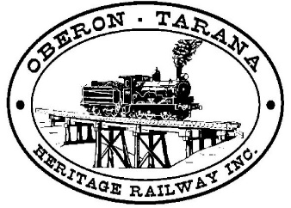  PO Box 299  Oberon NSW 2787  ABN 98 107 506 208 | Version | Author | Reviewed | Reference
 | A-Rev 2 | SMS Work party | Committee | SOP-007
 | 23/04/2018
 | Hand Signals

Document Status
Version | Date | Revision | Prepared | Reviewed | Approved
A | 23/11/2011 |  | Ian Davis | Committee | 24/11/2011
A-Rev 1 | 24/11/2011 | 1
A-Rev 2 | 09/04/2018 | 2 | SMS Working Party | Committee | 23/04/2018

Revision Record
Revision | Date issued | Description of Changes
1 | 24/11/2011 | Review
2 | 09/04/2018 | Change in format, (current 2017) hand signals

Hand Signals
SOP-007

1: Introduction
To prescribe the rules for giving and responding to hand signals used in the Network.
2: Responsibilities Giving hand signals
Hand signals must be given:
• in a clear and timely manner, and
• so that they will be received and acted upon only by those who are being signalled.
A Hand signaller must:
• be in or have access to a safe place, and
• be in clear view of those who are being signalled, and
• as required, have effective communication with Signallers or Protection Officers. Responding to hand signals If the meaning of a hand signal is not understood, Drivers and Track Vehicle Operators must stop to find out the meaning. Drivers and Track Vehicle Operators must:
• obey hand signals, and
• acknowledge hand signals other than shunting hand signals
Hand signalling
Hand signals must be given using:
• flags or hands during daylight, and
• lights during darkness and low visibility.
A hand signal must be continued:
• for the PROCEED and CAUTION hand signal, until the cab of the leading rail vehicle has passed the Hand signaller, and
• for STOP hand signals, until the rail traffic has stopped. If at a signal, a Hand signaller must:
• be able to see whether the signal is at STOP, and
• if rail traffic is required to stop, give a STOP hand signal until rail traffic has stopped. If the signal being held at STOP clears, the Hand signaller must:
• tell the Signaller to set the signal at STOP, and
• tell the Protection Officer, if provided. A Hand signaller must stand well away from signals if:
• rail traffic is not required to stop, or
• not signalling at a signal.
STOP hand signals Drivers and Track Vehicle Operators must stop their trains or track vehicles if they, or other crew members, receive a STOP hand signal given by:
• a red flag, or
• a red light, or
• both hands held high.
All CLEAR hand signals Drivers or Track Vehicle Operators must sound the whistle to acknowledge an ALL CLEAR hand signal given by:
• a white light, or
• one hand held high.
DANGER hand signals Drivers or Track Vehicle Operators must stop their trains or track vehicles immediately if they, or other crew members, receive a DANGER hand signal given by vigorous waving of arms, a flag or a light.
General hand signals
The following diagrams show the hand signals that must be used in the Network.

Stop 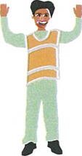 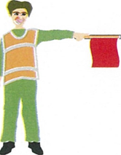

Proceed with caution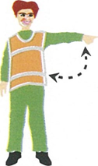 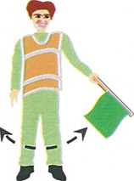

Proceed at normal speed 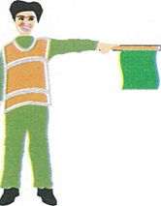
Acknowledgement - I see you and it’s all clear to pass 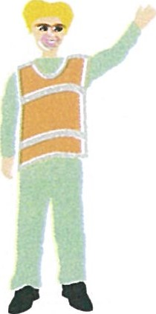

Shunting hand signals
Shunting hand signals must be given as necessary until the end of the planned movement.

Move away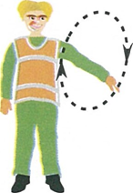Move away with caution 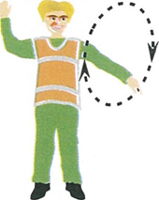

Move towards me 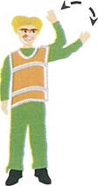Move towards me with caution 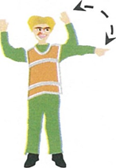

Release Automatic Air Brakes 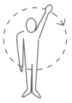

3: Related Documents
- TRG-001 Track Maintenance Vehicles Operators Training
- TRG-002 On the ground shunter
- SOP-005 Shunting – Yard Operation
- SOP-012 Shunting Rollingstock using a Tractor

