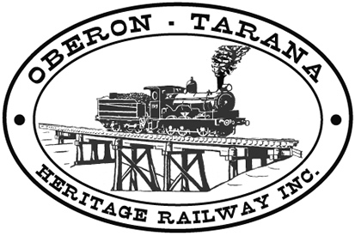 | PO Box 299  Oberon NSW  2787  ABN 98 107 506 208 | Version | Author | Reviewed | Reference
 | PO Box 299  Oberon NSW  2787  ABN 98 107 506 208 | B - Rev 1 | SM | SEC/TM | TB-003
 | PO Box 299  Oberon NSW  2787  ABN 98 107 506 208 | 26 July 2009
 | PO Box 299  Oberon NSW  2787  ABN 98 107 506 208 | RAIL JACKS
Work Area: ………………………………… Start Time: ………………………
Work Crew: ……………………………………………………………………………
Location: ………………………………… Date: …………………………….
Team Leader: …………………………… Presenter: …………………………………
Topic: Safe Use of Rail Jacks
- Rail Lifting Jacks can be heavy – lighter aluminium jacks can be lifted by one person but if in doubt – share the load with another team member. The National Code of Practice: Manual Handling indicates that the risk of injury increases when lifting weights above the range of 16-20 kg. (weights over 55 kg should not be lifted without mechanical assistance or team lifting);
- Be aware of the method of operating the jack prior to use - have your Team Leader demonstrate the correct technique.
- Use gloves when handling jacks.
- Watch for “pinch points” (EXPLAIN) when lifting and using jacks.
- The jack should be seated on a firm and level base before lifting commences.
- Ensure the load is always taken over the entire base of the jack.
- When lifting rail with multiple jacks, keep the jacks reasonably close together and only lift the rail just sufficiently to carry out task.
- Ensure the lifting section of the jack is fully engaged with the rail (or sleeper).
- Always use the correct operating handle matched to the jack.
- Practise the correct method for lowering different styles of jack before using in operations.
- Make sure all personnel are clear of sleepers (particularly feet) before lowering the jack. Call a warning in a LOUD VOICE as when released the load falls in an uncontrolled manner to the ground.
- These lifting jacks are expensive so keep them in good order.
- Report any defective equipment to your team leader who will tag it “Out of Service”.
- Any QUESTIONS or COMMENTS?
The Presenter must record any questions or comments on the back of this form

Please sign that you have attended and that you understood the content of this meeting:
Name | Signature | Name | Signature

