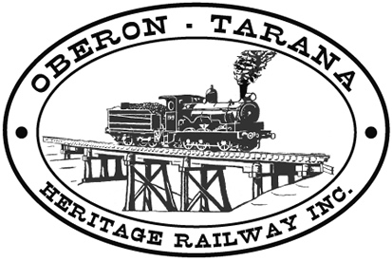 | PO Box 299  Oberon NSW  2787  ABN 98 107 506 208 | Version | Author | Reviewed | Reference
 | PO Box 299  Oberon NSW  2787  ABN 98 107 506 208 | B - Rev 1 | SM | SEC/TM | TB-007
 | PO Box 299  Oberon NSW  2787  ABN 98 107 506 208 | 26 July 2009
 | PO Box 299  Oberon NSW  2787  ABN 98 107 506 208 | Fatigue Management
Work Area: ………………………………… Start Time: ………………………
Work Crew: ……………………………………………………………………………
Location: ………………………………… Date: …………………………….
Team Leader: …………………………… Presenter: …………………………………
Topic: Fatigue Management
- Purpose: to reduce the errors, incidents and accidents in which fatigue is a contributing factor.
- Make sure you are fit and well rested. This is your responsibility.
- Use rest periods in addition to scheduled meal breaks.
- Use plant, machinery and equipment to eliminate or reduce the excessive physical demands of the job.
- Scientific studies suggest that people who are fatigued are unable to identify their own level of impairment – watch your co-workers for symptoms.
- Know the symptoms of Fatigue:
  - feeling drowsy,
  - yawning,
  - losing concentration,
  - impatience or irritability,
  - delayed reaction times.
- Be aware that some medications cause drowsiness and must not be used before using machinery or carrying out complex plant operations.
- Use rotational rosters when using heavy machinery or for arduous tasks.
- Be aware of OTHR Emergency Procedures (check wall charts and Toolbox TB-004).
- Any QUESTIONS or COMMENTS?
The Presenter must record any questions or comments on the back of this form

Please sign that you have attended and that you understood the content of this meeting:
Name | Signature | Name | Signature

