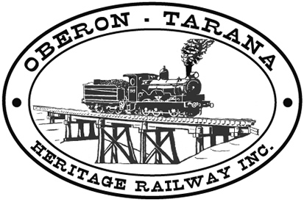 | PO Box 299  Oberon NSW  2787  ABN 98 107 506 208 | Version | Author | Reviewed | Reference
 | PO Box 299  Oberon NSW  2787  ABN 98 107 506 208 | B - Rev 2 | SM | GLP/ID | TB-012
 | PO Box 299  Oberon NSW  2787  ABN 98 107 506 208 | 12th August 2012
 | PO Box 299  Oberon NSW  2787  ABN 98 107 506 208 | Common Fire Extinguishers
Work Area: ………………………………… Start Time: ………………………
Work Crew: ……………………………………………………………………………
Location: ………………………………… Date: …………………………….
Team Leader: …………………………… Presenter: …………………………………
Topic: Common Fire Extinguishers
WHEN ARRIVING AT AN UNFAMILIAR WORKPLACE
- Check where fire extinguishers are located on the current work site (note locations now!)
- Determine how to raise a general fire alarm
IN CASE OF FIRE
- Raise the alarm;
- Choose the correct type of extinguisher for the class of fire (see below).
  - Do NOT discharge Water onto an electrical fire or flammable liquid fires.
  - Do NOT discharge Foam onto an electrical fire.
- Remove the safety pin by pulling it sharply. Briefly test the extinguisher before proceeding to the fire by squeezing the rigger handle.
- Try to work in pairs for safety.
- Hold the hose near the nozzle or hold any moulded handles.
- Always back away from a fire
- Always lay the extinguisher down on its side when empty.
- If you cannot put the fire out with one extinguisher then the fire is too big to fight.
- Remember “PASS” to guide your procedure:
- Pull the Pin,
- Aim Low at base of fire,
- Squeeze the handle,
- Sweep from side to sid

- EXTINGUISHER TYPES:
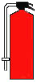 | 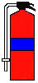 | 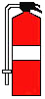
Red – Water – for wood, paper, rags, grass | Red with Blue stripe – Foam, as for Water type but also for flammable liquids (old standard was all blue) | Red with WHITE stripe - Dry Powder, as for the others but also for gases and electrical fires

Any QUESTIONS or COMMENTS?
The Presenter must record any questions or comments on the back of this form

Please sign that you have attended and that you understood the content of this meeting:
Name | Signature | Name | Signature

