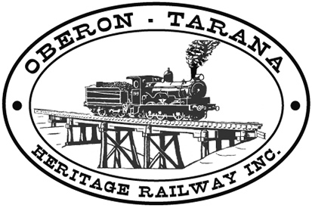 | PO Box 299  Oberon NSW  2787  ABN 98 107 506 208 | Version | Author | Reviewed | Reference
 | PO Box 299  Oberon NSW  2787  ABN 98 107 506 208 | B - Rev 2 | SM | GLP/ID | TB-013
 | PO Box 299  Oberon NSW  2787  ABN 98 107 506 208 | 1st September 2012
 | PO Box 299  Oberon NSW  2787  ABN 98 107 506 208 | Site Access
Work Area: ………………………………… Start Time: ………………………
Work Crew: ……………………………………………………………………………
Location: ………………………………… Date: …………………………….
Team Leader: …………………………… Presenter: …………………………………
Topic: Site Access
- Purpose:- To ensure safe access rules for both pedestrians and motor vehicles.
- Recommendations – Pedestrians.
  - Where a footpath has been provided for crossing the rail corridor – use it;
  - Check for oncoming rail traffic prior to crossing;
  - Check for motor vehicles and construction equipment;
  - Do not enter non-public areas of the rail corridor if you do not hold a current safety induction certificate;
  - Fill in the “Sign-on” book as soon as you arrive including listing the expected Job Task Number (SN-003 see inside cover of Sign-on book).
  - Learn where the entry and exit points are. For emergency purposes Stage 1 (Oberon to Hazelgrove) is divided into 2 Sections:
  - RED Section – Oberon Station to Tip Road SN-012
WHITE Section – Tip Road to Hazelgrove Station SN-011
These maps are displayed at the work base and show access points and emergency procedures.
Always work within the confines of the rail corridor.
Do not obstruct the walking trail.
If you leave the site early, notify your team leader and “Sign off”.
Recommendations – Motor Vehicles
- Where access is to developed areas such as Oberon Station use the designated car parking areas.
- Determine whether private motor vehicles are allowed onto the work site;
- Ensure that your vehicle is suitable for the track to be used;
- Ensure that you park in a manner to allow access by emergency vehicles;
- Any QUESTIONS or COMMENTS?
The Presenter must record any questions or comments on the back of this form

Please sign that you have attended and that you understood the content of this meeting:
Name | Signature | Name | Signature

