 | PO Box 299  Oberon NSW  2787  ABN 98 107 506 208 | Version | Author | Reviewed | Reference
 | PO Box 299  Oberon NSW  2787  ABN 98 107 506 208 | B - Rev 1 | SM | SEC/TM | TB-015
 | PO Box 299  Oberon NSW  2787  ABN 98 107 506 208 | 26 July 2009
 | PO Box 299  Oberon NSW  2787  ABN 98 107 506 208 | St John DRABCD Action Plan
Work Area: ………………………………… Start Time: ………………………
Work Crew: ……………………………………………………………………………
Location: ………………………………… Date: …………………………….
Team Leader: …………………………… Presenter: …………………………………
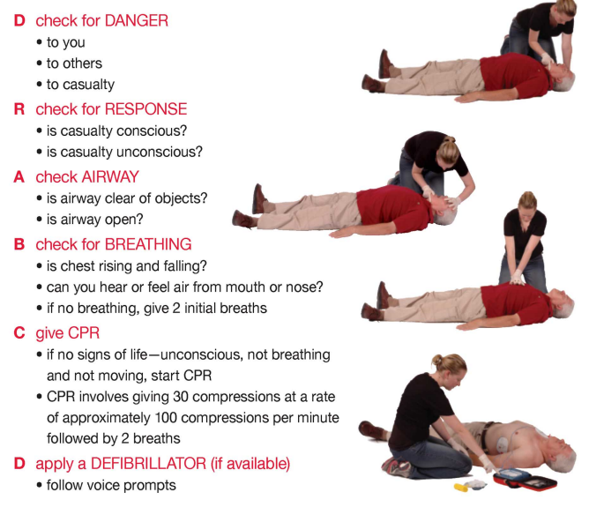
- Any QUESTIONS or COMMENTS?
The Presenter must record any questions or comments on the back of this form

Please sign that you have attended and that you understood the content of this meeting:
Name | Signature | Name | Signature

