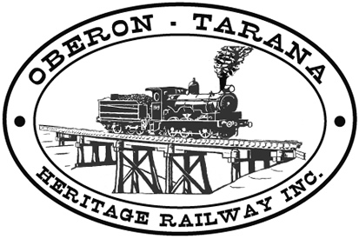 | PO Box 299  Oberon NSW  2787  ABN 98 107 506 208 | Version | Author | Reviewed | Reference
 | PO Box 299  Oberon NSW  2787  ABN 98 107 506 208 | B - Rev 3 | SM | GLP/ID | TB-016
 | PO Box 299  Oberon NSW  2787  ABN 98 107 506 208 | 03/09/12
 | PO Box 299  Oberon NSW  2787  ABN 98 107 506 208 | Working With Mobile Machinery
Work Area: ………………………………… Start Time: ………………………
Work Crew: ……………………………………………………………………………
Location: ………………………………… Date: …………………………….
Team Leader: …………………………… Presenter: …………………………………
Topic: Working With Mobile Machinery
Purpose:- One of the major hazards on worksites is the operation of mobile equipment at, or near the site being carried out by other workers. The following recommendations apply to mobile equipment such as backhoes, cranes, excavators etc and not to static machinery such as lathes and milling machines.
Recommendations – Mobile Equipment.
If you are the operator:-
- No person must drive or operate any vehicle, mobile or other equipment unless they have been properly trained and authorised to do so. Where necessary the appropriate certificate or license must be held and shall be shown on the operator’s Certificate of Competency ID card.
- The machine should be operated at a speed appropriate to the work place.
- Ensure that other workers are aware of your planned activity and the limits of your operational area.
- Advise the team leader if you notice faulty or damaged machinery or unsafe practices
- Machinery must be shut down if you have to check, clean or carry out maintenance.
- Moving machinery has pinch points and hazardous moving parts - take care.
- Never wear loose clothing or long hair near rotating machinery eg. PTO shafts.
If you are working nearby mobile equipment:-
- If possible, avoid working near any moving machinery.
- Keep other people clear of moving machinery - watch out for your fellow workers.
- Keep unauthorised personnel clear of the work site.
- Wear appropriate PPE including hard hat if closer than 5m from the edge of the Swing Zone.
The Swing Zone is a circular area, the radius of which is measured from the centre of the machine to the outside edge of the implement or gripped object when the machine is at full extension.
- Never work or enter the “Swing Zone”. Maintain the minimum 5m clearance at all times. Ask your supervisor if you are unsure.
- If mobile equipment is operating nearby, designate a “spotter” to observe & control traffic movement.
- The spotter must be visible to the machine operator.
- If possible, erect safety barriers and warning signs around operating machinery.
- Never approach a machine operator from their blind side.
- Always gain the operators attention and ensure the machine has stopped prior to approaching the driver’s compartment.
- Advise the team leader if you notice faulty or damaged machinery or unsafe practices.
- Any QUESTIONS or COMMENTS?
The Presenter must record any questions or comments on the back of this form
Please sign that you have attended and that you understood the content of this meeting:
Name | Signature | Name | Signature

