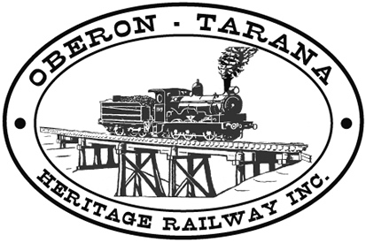 | PO Box 299  Oberon NSW  2787  ABN 98 107 506 208 | Version | Author | Reviewed | Reference
 | PO Box 299  Oberon NSW  2787  ABN 98 107 506 208 | B - Rev 2 | SM | GLP/ID | TB-017
 | PO Box 299  Oberon NSW  2787  ABN 98 107 506 208 | September 2012
 | PO Box 299  Oberon NSW  2787  ABN 98 107 506 208 | Personal Hygiene
Work Area: ………………………………… Start Time: ………………………
Work Crew: ……………………………………………………………………………
Location: ………………………………… Date: …………………………….
Team Leader: …………………………… Presenter: …………………………………
Topic: Personal Hygiene
Purpose To ensure that all workers in a team demonstrate personal hygiene standards that ensure fellow workers do not contact infectious illness and that you fit into the work team.
Recommendations:-
- OTHR expects its volunteers and employees to demonstrate high levels of personal hygiene when operating as part of a team and when interacting with the public.
- Good personal hygiene is one of the most effective ways to protect ourselves, and others, from illness.
- Workers who are sick, particularly with contagious illnesses such as ‘influenza, should stay at home to prevent infection of other workers.
- OTHR provides amenities for workers to maintain personal hygiene including toilets and hand washing facilities. The state of these facilities should be monitored by workers and deficiencies reported to the team leader.
- Appropriate clothing including PPE should be used to help our workers maintain personal hygiene.
- Volunteers involved in food handling should be familiar with the NSW Food Authority “Food Handling Guidelines for Temporary Events” (available on site).
- Basic personal hygiene practices for food handlers include thoroughly washing and drying hands before handling food and after:
    - visiting the toilet
    - blowing your nose or coughing
    - smoking
    - handling raw food or waste,
- Rubbish, such as food scraps and drink containers must not be left at workplaces – use the bins provided or take the waste back home with you.
- A covered and protected facility is available for meals and this should be used to maintain health standards during food preparation and serving.
- Any QUESTIONS or COMMENTS?
The Presenter must record any questions or comments on the back of this form
Please sign that you have attended and that you understood the content of this meeting:
Name | Signature | Name | Signature

