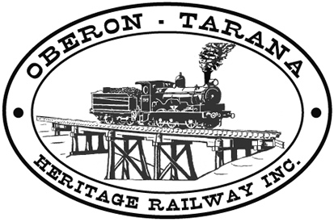 | PO Box 299  Oberon NSW  2787  ABN 98 107 506 208 | Version | Reviewed By | Reference
 | PO Box 299  Oberon NSW  2787  ABN 98 107 506 208 | B - Rev 0 | Sec/SM | TB-019
 | PO Box 299  Oberon NSW  2787  ABN 98 107 506 208 | May - 2009
 | PO Box 299  Oberon NSW  2787  ABN 98 107 506 208 | Site Access

Work Area: ………………………………… Start Time: ………………………
Work Crew: ……………………………………………………………………………
Location: ………………………………… Date: …………………………….
Team Leader: …………………………… Presenter: …………………………………

Topic: Drugs and Alcohol

- Workers must not be adversely affected by alcohol or drug use during working hours and must at all times carry out their duties and responsibilities in a safe manner.
- Members are responsible for absenting themselves from work if they are under the influence of alcohol or other drugs.
- Drugs and alcohol are not permitted on the work site.
- You are obliged to notify the team leader if you are concerned about possible D & A effects on other workers.
- If on prescribed medication, advise the team leader prior to starting - some medications can affect your ability to work safely.
- Drugs and Alcohol will affect: 1) Reaction time,
2) Co-ordination,
3) Judgment,
4) Your ability to carry out the tasks allotted to you.
- Read & understand: POL-004 “Drug & Alcohol Policy and Program”
(also available on the web)
- Any QUESTIONS or COMMENTS?
The Presenter must record any questions or comments on the back of this form
Please sign that you have attended and that you understood the content of this meeting:

ATTENDEES:
Name | Signature | Name | Signature

