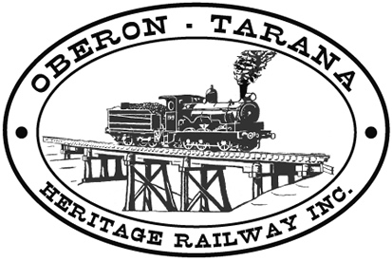 | PO Box 299  Oberon NSW  2787  ABN 98 107 506 208 | Version | Reviewed By | Reference
 | PO Box 299  Oberon NSW  2787  ABN 98 107 506 208 | B - Rev 0 | Sec/SM | TB-021
 | PO Box 299  Oberon NSW  2787  ABN 98 107 506 208 | October - 2009
 | PO Box 299  Oberon NSW  2787  ABN 98 107 506 208 | Site Access

Work Area: ………………………………… Start Time: ………………………
Work Crew: ……………………………………………………………………………
Location: ………………………………… Date: …………………………….
Team Leader: …………………………… Presenter: …………………………………
Topic: What is Cat 3 Rail Safety Work?
- All workers under the Rail Safety Act are required to be certified into four categories. Cat 1 & 2 carry out High Level Safety Critical tasks. They require a comprehensive physical and psychological assessment to detect conditions that may affect safe working ability.
- Non-Safety Critical Workers (Around the Track Personnel-ATTP) are those whose health and fitness will not impact directly on the public or the rail network. However, these workers must be able to protect their own safety and that of fellow workers.
- Category 3 rail safety work is carried out in an un-controlled environment, that is, all rolling stock movements are run as per the Operations Manager’s daily program.
- Category 3 workers are required to have a Track Safety Health Assessment, which involves assessment of hearing, vision and mobility.
- Frequency of Health Assessment for Cat 3: At time of commencement then at 40 years of age and 5 yearly thereafter.
- All members are required to have Track Safe training at this point.
- No Category 4 personnel are permitted to work in the un-controlled section.
- Any QUESTIONS or COMMENTS?
The Presenter must record any questions or comments on the back of this form
Please sign that you have attended and that you understood the content of this meeting:
Name | Signature | Name | Signature

