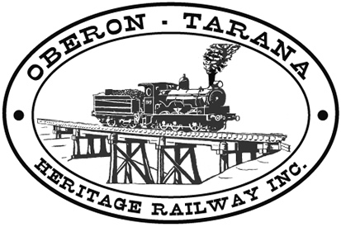 | PO Box 299  Oberon NSW  2787  ABN 98 107 506 208 | Version | Reviewed By | Reference
 | PO Box 299  Oberon NSW  2787  ABN 98 107 506 208 | B - Rev 3 | Sec/SM | TB-022
 | PO Box 299  Oberon NSW  2787  ABN 98 107 506 208 | October - 2009
 | PO Box 299  Oberon NSW  2787  ABN 98 107 506 208 | Category 4 Rail Safety Work

Work Area: ………………………………… Start Time: ………………………
Work Crew: ……………………………………………………………………………
Location: ………………………………… Date: …………………………….
Team Leader: …………………………… Presenter: …………………………………

Topic: What is Category 4 Rail Safety Work?

- All workers under the Rail Safety Act 2008 are required to be certified into four categories. Cat 1 & 2 carry out High Level Safety Critical tasks. They require a comprehensive physical and psychological assessment to detect conditions that may affect safe working ability.

- Non-Safety Critical Workers (Around the Track Personnel-ATTP) are those whose health and fitness will not impact directly on the public or the rail network. However, these workers must be able to protect their own safety and that of fellow workers.

- Category 4 rail safety work is carried out in a controlled environment, that is, all motorised rail movements are restricted, and members / workers are not required to have medicals or mobility tests under the Act.

- Category 4 is considered the base entry point for all members and is the starting point for future operations.

- Contrast this to Category 3 rail safety work which is carried out in an un-controlled environment and requires Track Safe Training and Health Assessment.

- Any QUESTIONS or COMMENTS?
The Presenter must record any questions or comments on the back of this form
Please sign that you have attended and that you understood the content of this meeting:

Name | Signature | Name | Signature

