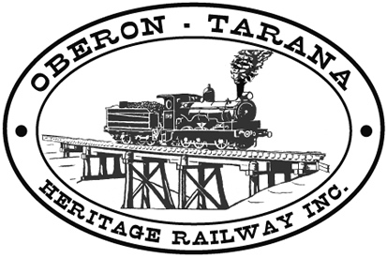 | PO Box 299  Oberon NSW  2787  ABN 98 107 506 208 | Version | Author | Reviewed | Reference
 | PO Box 299  Oberon NSW  2787  ABN 98 107 506 208 | A - Rev 0 | SM | SEC/RM | TB-033
 | PO Box 299  Oberon NSW  2787  ABN 98 107 506 208 | Doc Date: 27 April 2010 |  | Mgt. Approval ………..
 | PO Box 299  Oberon NSW  2787  ABN 98 107 506 208 | Prohibition - Riding on Rollingstock
Work Area: ………………………………… Start Time: ………………………
Work Crew: ……………………………………………………………………………
Location: ………………………………… Date: …………………………….
Team Leader: …………………………… Presenter: …………………………………
Topic: ITSRR Prohibition - Riding on Rollingstock
The Safety Regulator has issued Rail Industry Safety Notice (RISN) #20, Aug 2007 which states:
- Persons are prohibited from riding on a unit of rolling stock whilst the unit is in motion.
- Riding within a designated operating position or other enclosed space specifically designed to protect persons during the movement of the rolling stock is not prohibited.
- This applies to all rolling stock except that designed for the carriage of passengers or persons.”
For example, the Prohibition Notice would prohibit persons riding on flat top wagons.

ITSRR does not consider the following to be designated safe places:
- riding on rolling stock where the person extends outside the rolling stock outline and is exposed to the risk of being struck by rail structures
- riding on ladders or steps of moving rolling stock
- riding on freight wagons (which are designed for freight, not people)
- alighting or disembarking from moving locomotives by the external ladder
- riding anywhere where the risk of a person falling under, between or into the path of rolling stock is foreseeable
- riding on rolling stock where steel guard rails are in place but a person can still fall between the guard rails if, for instance, the person loses consciousness.

Action
All affected operators must ensure they have in place appropriate systems and procedures as part of their safety management system:
- Risk assessments involving rollingstock must include this prohibition - add it if it is not there.
- Team leaders and train crew must ensure that employees, volunteers and contractors do NOT ride on rolling stock unless in a designated safe position.
Any QUESTIONS or COMMENTS? The Presenter must record any questions or comments on the back of this form

Please sign that you have attended and that you understood the content of this meeting:
Name | Signature | Name | Signature

