Document Status
Version | Date | Revision | Prepared | Reviewed | Approved
A | 22/3/16 | 0 | IDavis/TArnison | 22/3/16 | Committee

Revision Record
Revision | Date Issued: | Description of change:
0 | 14/0816 | Minor word changes

AUDIT POLICY

OTHR Management Committee is responsible for establishing and managing the audit program. Three levels of auditing may be undertaken:
- Internal compliance audits – performed by OTHR members (members, rail safety workers, contractors) with relevant experience and knowledge of position responsibilities, but independent of the position being audited.
- Internal Operational Audits – performed by OTHR managers on a regular basis
- External compliance audits are carried out by the Rail Safety Regulator.

Summary of the Process:
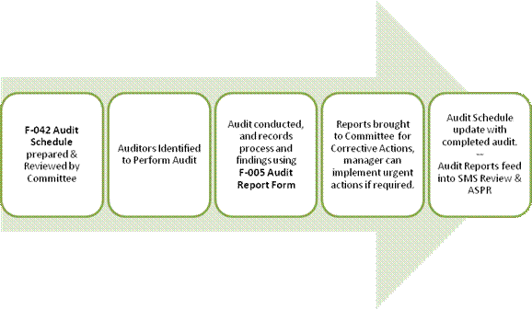

Audit Scheduling
The program is run on a triennial basis, according to the prepared F-042 Audit Schedule. This schedule may vary as a result of changes to audit priorities or if additional audit requirements are identified. The Audit Schedule makes provision for all rail safety related activity to be audited at least once in each three year period.
The Management Committee prioritises the internal audit program taking into account various factors including:
- Previous audit findings and recommendations
- Recent rail safety performance
- Status and importance of activities to be audited, with particular consideration in giving high risk activities priority
The schedule is updated with the date each audit is completed, and the audit program is monitored at meetings of the Management Committee to make sure audits are proceeding according to schedule.

Conducting an Audit
The persons nominated to conduct Audits are largely responsible for determining the content of the audit, and preparing a check list of questions. The auditor will liaise with the relevant manager to gain access to the required documents and personnel.

Audit Reporting
Findings are documented on the Audit Report Form F-005, which will include details of the scope & audit, observations and non-conformances, a judgement about the compliance of the related documents and verification of correction actions performed as a result of previous audits.
Any independent or external audits shall include the requirement to provide a written audit report.
Audit reports are given to the Manager and are reviewed at Management Committee meetings which will determine appropriate corrective actions. Corrective action items will be brought forward at each subsequent meeting until they are completed.
(Refer Corrective Actions)
Where findings from audits require urgent attention the Manager can assign corrective action items for the attention of relevant staff or arrange to convene a Management Committee meeting to review the findings and assign action.

