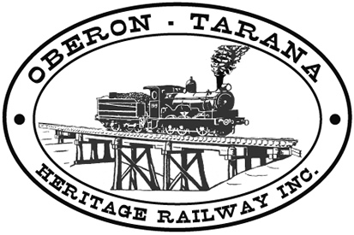 | PO Box 299  Oberon NSW  2787  ABN 98 107 506 208 | Version | Author | Reviewed | Reference
 |  | A - Rev 1 | SM | SEC/TM | SOP-001B
 |  | 08/09/12
 |  | TMV/Section Car - Safety Check

Appendix “B”: SECTION CAR SAFETY CHECK.

(Complete in duplicate – driver retains Original)

Authority #……………….. Date Issued……………….. Time Issued…………

Before use, the following safety checks were carried out to the best of my ability and I
Consider that the Section Car is in safe working order ………………………………
Signed – Driver

[TICK IF SATIFACTORY] Tick

- The RED danger flag is in place on the Section Car. …….
- The fire extinguisher is in place and within use-by date. …….
- All crew are financial Members of OTHR. …….
- All crew are wearing PPE including SAFETY VESTS. …….
- The total number of crew is 4 or less. …….
- There are no fuel leaks. …….
- Wheels appear secure and not fractured. …….
- There are no obviously damaged mechanical parts. …….
- The brakes check OK when tested. …….
- The rotating safety beacon is tested and switched ON. …….
- The horn is tested and working. …….
- Lights (if fitted) are working. …….
- Tools and equipment are loaded safely and suitably restrained. …….
- All crew can be safely seated within the confines of the car. …….
- Other personnel are made aware that operations are about to commence. …….

ORIGINAL TO BE RETURNED
TO THE DOCUMENT CONTROLLER

